CAMP CREATION II, June 21st-25th 8:30a.m.-3:30 p.m.
The Great Outdoors
“And God saw everything that He had made, and behold, it was very good.”

This year Camp Creation II students are being thrust into EXPLORATION! Living in the midst of the unique Loess Hills of western Iowa, campers will have opportunities to take day trips to nearby sites that have a story to tell. They will get firsthand experience investigating the birds, fish, waters and soils near us and the explorers who documented them. Most of your student’s time at this camp will be spent outside in God’s Great Outdoors!
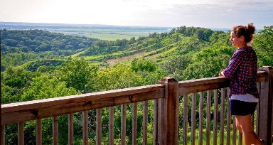
June 21st- Hitchcock Nature Center
Focus: Birds, Contact: Amy Campagna, 712-242-1189
Hitchcock Nature Center, located in Honey Creek, Iowa straddles the Loess Hills of Western Iowa. A county treasure, Hitchcock has a beautiful learning center with classrooms, a hawk watch deck, a 45’ observation tower, an archery range and miles of lovely trails. Campers will engage in two different hikes, a birdwatching investigation and a group presentation introducing the concept of biomimicry called, “It’s a bird…it’s a plane!”
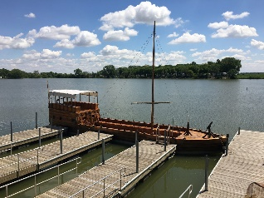
June 22nd- Lewis and Clark State Park, Onawa Iowa
Focus: God’s Creation from the eyes of Lewis and Clark, Contact: “Lizard,” 423-2829
Students will be excited to learn all about the Lewis and Clark Expedition from the professional historian and Park Specialist “Lizard.” In session I, campers will be shown animal furs, maps and original tools. They will also get “all hands on deck” with a replica of the original keel boat used by the explorers. Other sites will include a nature hike and miniature boat build.

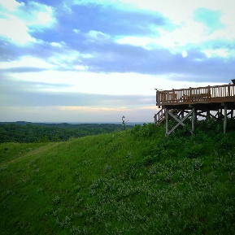
June 23rd- Loess Hills State Forest, Preparation Canyon
Focus: Soil, Contact visitor center, 712-456-2924
Students will certainly have heard of the Loess Hills being from western Iowa, but how many of them have spent time digging in these hills, hiking on them or inspecting them? The Loess Hills rise 200 feet above the flat plains below. Guest presenter Martin Cannon, will join us in the morning this day to teach us more about the hills and the soil. Students will again rotate between two different hikes, a picnic in the hills, and exploratory session of soil types.

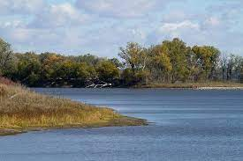
June 24th- Desoto Bend Wildlife Refuge
Focus: Water, Contact the Refuge Office at 712-388-4800
Students will enjoy the natural beauty and sounds of creation at the refuge. Our group will be dropped off at a shelter where three different short hiking trails merge. Rotations will include two hikes which will incorporate bird and animal watching and identification. A group presentation will relate to the Missouri River and wildlife photography. After morning sessions, the day will conclude at adjacent Wilson Island State Recreation Area for fun free time activities.

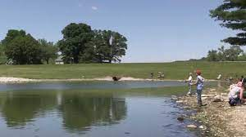
June 25th- Arrowhead Park, Neola Iowa
Focus: Fish, Contact the Park Office at 712-485-2295
Arrowhead Park, located in Neola Iowa, is a pleasant park with a nice fishing lake and hiking trails. On this final day of Camp Creation we will begin in the Lodge with our special guest Elaine Goodwin. Elaine recently had her arms and legs amputated due to an illness and is thankful to God for sparing her life. Now, she is challenged to figure out how to function with her limitations. Elaine will not only inspire students toward thankfulness and an appreciation of what God has given them, but will also teach them how God’s creation is indeed very good! Activities will involve fishing, hiking and recreation. Students can leave their lunches at home and enjoy a grilled hotdog or hamburger on this day, along with chips, fruit and a cookie!

Contact info for parents and bus drivers:

Departing Location: 239 Frank Street, Council Bluffs, IA 51503.
Each day, campers will depart from St. Paul’s at 8:30 a.m. and return by 3:30 p.m.

June 21st: Destination is Hitchcock Nature Center in Honey Creek, IA
27792 Ski Hill Loop, Honey Creek, IA 51542

June 22nd: Destination is Lewis and Clark State Park, Onawa IA
21914 Park Loop, Onawa, IA 51040

June 23rd: Destination is Loess Hills State Forest, Preparation Canyon
340th St, Moorhead, IA 51558

June 24th: Desoto Bend Wildlife Refuge
1434 316th Ln, Missouri Valley, IA 51555

June 25th: Arrowhead Park, Neola Iowa
29357 310th St, Neola, IA 51559

