Camp Creation I, June 14-18 2021 (9:00am-Noon)
Ages 3 through 2nd grade (grade just completed)
“WE ALL BELIEVE IN ONE TRUE GOD”

Camp Creation I is the annual week long camp for 3 year olds through 2nd graders held at St. Paul’s Lutheran Church. Focus for each half day is a different day of Creation. Register at church ahead of time or by calling 712-322-4729.

Monday
Creation Days 1-2: Theme- “God made Day and Night, Heaven and Earth.”
Memory-Genesis 1:6a, “Let there be an expanse in the midst of the waters…”
Lesson: “God Uses Clouds to Lead, Cover and Reveal.” This study will focus upon the first two days of creation and then track some of the times God used clouds in the Bible to carry out His plans. The “pillar of cloud” in the OT lead the children of Israel in the desert. The clouds covered Jesus at His Ascension. God promised to reveal His Son again at His second coming which included clouds.
Science: “Blessed By Clouds.” In this study, students will learn how the earth is blessed by clouds. Not only will they learn the different types of clouds, but also how clouds bring forth rain and moisture. Finally, they will be taught to recall God’s use of clouds in significant Old and New Testament texts, (more in the bible lesson), when they view clouds in the future.

Tuesday
Creation Days 3-4: Theme- “God Made the Seas and Land, Sun, Moon and Stars.”
Memory- Psalm 119:105, “Your word is a lamp to my feet and a light to my path.”
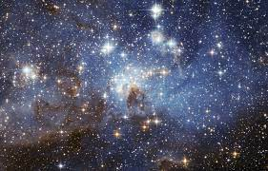
Lesson: “God uses stars in His plan of salvation.” This study will focus upon the third and fourth days of creation. Students will learn how God made a promise to Abram relating to the stars and how a single star led the wise men to the Christ-child. The message and guidance of the stars were very important in bring us to Jesus!
Science: “Blessed By Stars.” In this study, students will learn how people traveling across the oceans would use the stars for purposes of navigation. In a similar way that the wise men were led by stars, so others throughout history were led by stars to their destination. Students will explore various instruments and techniques from the past used for navigation. They will also learn the names of famous navigators.

Wednesday
Creation Day 5: Theme- “God Made the Creatures of the Sky and Sea.”
Memory- Matthew 6:26, “Look at the birds of the air; they neither sow nor reap nor gather into barns, yet your heavenly Father feeds them. Are you not of more value than they?”
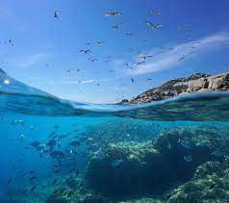
Lesson: “God Uses Fish and Birds to Teach Us.” In this study, students will learn how God has given mankind birds and fish as a blessing. In the Old Testament, God used a fish to teach Jonah a lesson and ultimately, tell us about Jesus’ resurrection. In the New Testament, God teaches the value of human life by considering the “birds of the air.”
Science: “Blessed by Birds and Fish.” “Blessed by birds and fish”. In this study, students will learn how the earth and people have been blessed by birds and fish. They will learn about some of the most interesting and beneficial birds and fish on the planet, their names, where they live and what they do, and why they are crucial to the world around them.

Thursday
Creation Day 6: Theme- “God Made the Creatures of the Dry Land.”
Memory- Matthew 21:5, “Say to the daughter of Zion, ‘Behold Your king is coming to you, humble, and mounted on a donkey, and on a colt, the foal of a beast of burden.’”
Lesson: “God Uses Land Animals to Help Mankind.” In this lesson, students will learn about God’s creation of animals. He made small animals, big animals, wild animals, livestock and domestic animals. An example of an animal specifically given to serve is the donkey that carried our Lord Jesus into Jerusalem on Palm Sunday!
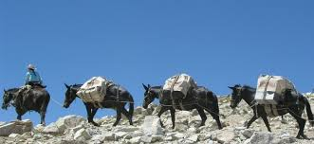
Science: “Blessed by Beasts of Burden.” “Blessed by beasts of burden”. In this lesson, students will learn about the animals that have helped mankind throughout history, not only horses and oxen, but donkeys, camels, and even elephants! The children will learn why these animals are perfectly suited to their tasks, and how God created them to be amazingly strong, smart, and capable. They will discover some startling and wonderful ways animals have helped man in the past and still do today!

Friday
Day 6-7: Theme- “God Made Humans/God Rested”
Memory- Psalm 139:14, “I praise you, for I am fearfully and wonderfully made.”
Lesson- “God Gave His Son Into human flesh.” On the final day of class, we will learn again how God made humans as the “crown” of His creation, that is, the most significant part! He gave humans a unique mind and a soul, made in His own image and likeness. Ultimately, in order to save the world from sin, God didn’t send a bird or fish, horse or donkey, He sent His Son “born of a woman, born under the law, to redeem those under the law.”
Science- “Blessed By Our Bodies and Lives.” “Blessed by our bodies and lives”. In this lesson, students will learn how remarkable their bodies are and how useful all of our parts are, especially the parts we don’t usually think of as important. They will learn why some of those parts are given to us to bless and protect our bodies. We will even have a very special guest who can help us understand how fearfully and wonderfully we are made!

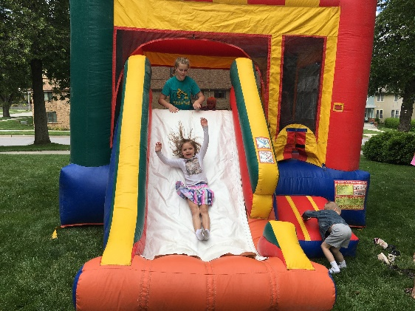
- Outdoor fun includes a bounce house on Thursday and Friday!

-Snacks are provided each day.

-Check your students in and out at the Perrin Street side entrance each morning.

