**All Saints’ Day**

**(((Observed**

“Behold, a great multitude that no one could number, from all tribes and peoples and languages, standing before the throne and before the Lamb, and crying out with a loud voice, “Salvation belongs to our God who sits on the throne, and to the Lamb! ”

Revelation 7:9-10

**Welcome**

Welcome to all members and visitors! We are pleased to have you with us as we receive Christ’s gifts and as we respond in thanks and praise. Guests, please sign the guest register in the narthex. If you need assistance, please ask one of the ushers. Prayers of preparation for worship can be found on the inside front cover of the hymnal.

**The Lord’s Supper is offered** every Sunday of the month. St. Paul’s observes the biblical practice of closed communion. **Members of sister congregations** of the Lutheran Church-Missouri Synod are encouraged to commune with us. We ask **visitors who are not members of the LCMS** to speak with one of our pastors if you are interested in learning more about our church and communion practices. Those not communing with us at this service are welcome to come forward to receive a blessing. Simply cross your arms to indicate this desire.

**Those Serving Us**

Preacher/Liturgist: Rev. Nathan Sherill

Pianist: Jonathon Schulz

Kantors: Derek Stephenson (8 a.m.); Brett Allen (10:45 a.m.)

**Kantor's notes:** Liturgical Significance:Read the names of the faithful departed listed elsewhere in this bulletin.

**Hymn of the Season:** “Holy God, We Praise Thy Name” (LSB 940) ([www.stpaulscouncilbluffs.org/hymns](http://www.stpaulscouncilbluffs.org/hymns))

**The Congregation at Prayer**

Those ill or recovering: *Mary Johannes, Jayne McIlrath, Elizabeth Bowerman, Karen Brandenburg, Gertrud Rossbund, Ryan Pedersen (son of Art & Julie Gardner), Trent Casey, John Shafer (father of Kelli Salin), Miles Maurice (grandson of Joel & Paulette Maurice),* *Tina Lamason (sister of Brad White), Marge Miller, Dawn Letcher (daughter of Tony and Shirley Gust), Cole (cousin of Kelli Salin), Lu Schwery (mother of Denise Krohn), the family of Shaylie Gardner, at the death of her Aunt Becky, at the death of her Aunt Becky, mother of Julie Moreno*

*Jerry Gaffney* and all our shut ins.

Our missionaries: Deaconess Sandra Rhein & Ms. Becky Bartelt

Our circuit congregations and pastors

Our nation, city, and community; Those serving in the armed forces

# Divine Service Setting 1

677 For All the Saints

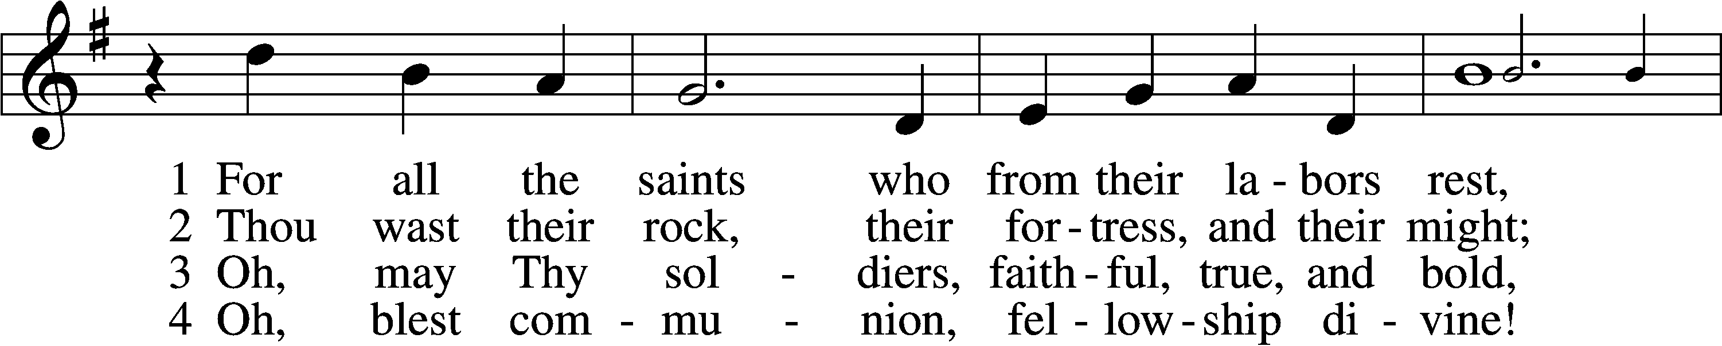

Kantorei

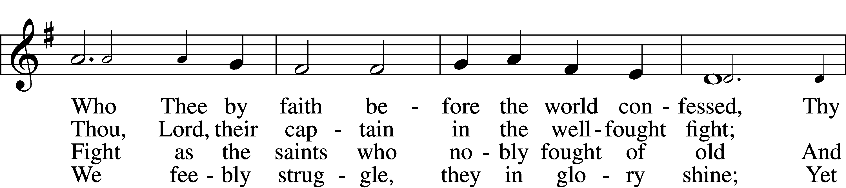

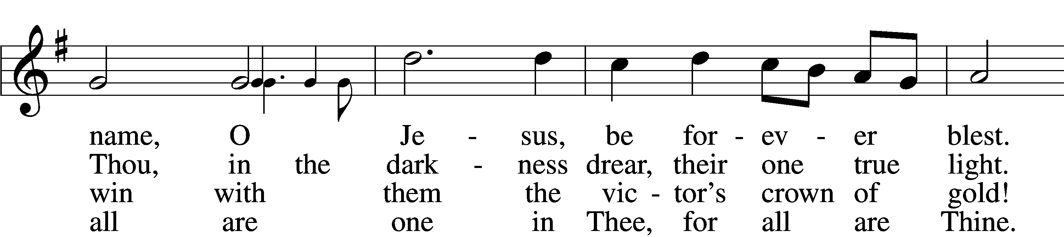

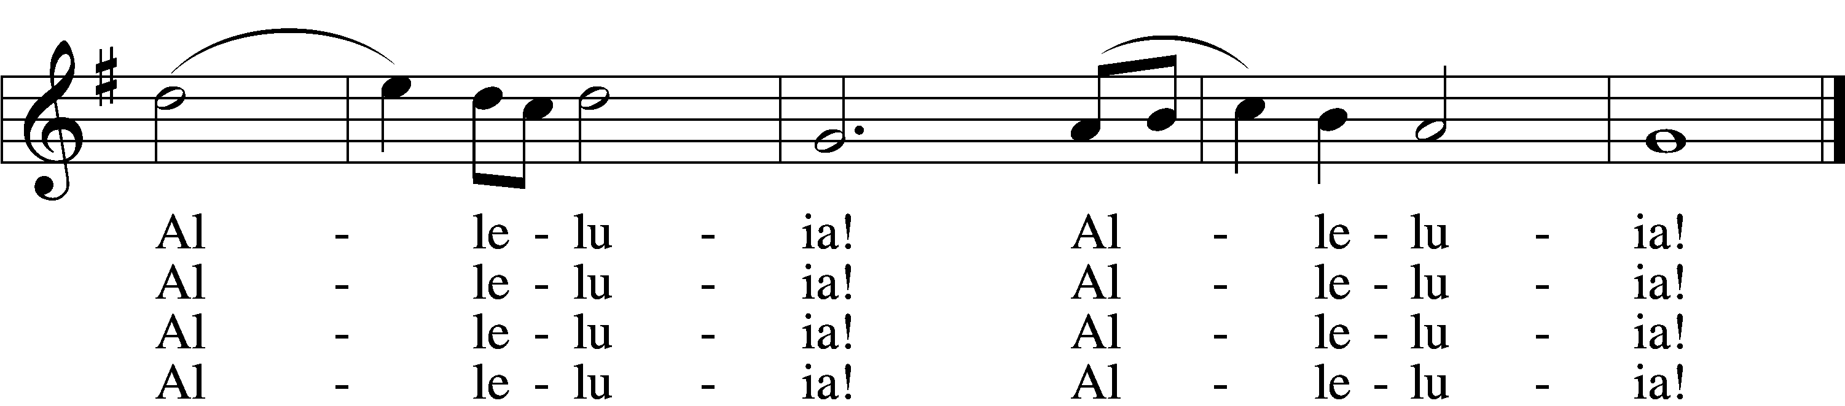

5 And when the fight is fierce, the warfare long,  
Steals on the ear the distant triumph song,  
And hearts are brave again, and arms are strong.  
 Alleluia! Alleluia!

Kantorei

6 The golden evening brightens in the west;  
Soon, soon to faithful warriors cometh rest;  
Sweet is the calm of paradise the blest.  
 Alleluia! Alleluia!

7 But, lo, there breaks a yet more glorious day:  
The saints triumphant rise in bright array;  
The King of Glory passes on His way.  
 Alleluia! Alleluia!

D 8 From earth’s wide bounds, from ocean’s farthest coast,  
Through gates of pearl streams in the countless host,  
Singing to Father, Son, and Holy Ghost:  
 Alleluia! Alleluia!

Text: William W. How, 1823–97, alt.  
Tune: Ralph Vaughan Williams, 1872–1958  
Text and tune: Public domain

Stand

The sign of the cross may be made by all in remembrance of their Baptism.

Invocation

P In the name of the Father and of the T Son and of the Holy Spirit.

C **Amen.**

Exhortation LSB 151

P If we say we have no sin, we deceive ourselves, and the truth is not in us.

C **But if we confess our sins, God, who is faithful and just, will forgive our sins and cleanse us from all unrighteousness.**

Silence for reflection on God’s Word and for self-examination.

Confession of Sins 151

Absolution LSB 151

P Almighty God in His mercy has given His Son to die for you and for His sake forgives you all your sins. As a called and ordained servant of Christ, and by His authority, I therefore forgive you all your sins in the name of the Father and of the T Son and of the Holy Spirit.

C **Amen.**

# Service of the Word

**Introit** *Psalm 31:1, 3, 5; antiphon: Revelation 7:14b*

These are the ones coming out of the great tribu- | lation.*  
 They have washed their robes and made them white in the blood | of the Lamb.  
**In you, O Lord, do I take refuge; let me never be | put to shame;*  
 in your righteousness de- | liver me.**  
For you are my rock and my | fortress;*  
 and for your name’s sake you lead me and | guide me.  
**Into your hand I commit my | spirit;*  
 you have redeemed me, O Lord, | faithful God.  
Glory be to the Father and | to the Son**\*  
 **and to the Holy | Spirit;**  
**as it was in the be- | ginning,**\*  
 **is now, and will be forever. | Amen.**  
These are the ones coming out of the great tribu- | lation.*  
 They have washed their robes and made them white in the blood | of the Lamb.

Kyrie LSB 152

A In peace let us pray to the Lord.

C **Lord, have mercy.**

A For the peace from above and for our salvation let us pray to the Lord.

C **Lord, have mercy.**

A For the peace of the whole world, for the well-being of the Church of God, and for the unity of all let us pray to the Lord.

C **Lord, have mercy.**

A For this holy house and for all who offer here their worship and praise let us pray to the Lord.

C **Lord, have mercy.**

A Help, save, comfort, and defend us, gracious Lord.

C **Amen.**

This Is the Feast LSB 155

C **This is the feast of victory for our God.**

**Alleluia, alleluia, alleluia.**

**Worthy is Christ, the Lamb who was slain, whose blood set us free to be people of God.**

**This is the feast of victory for our God.**

**Alleluia, alleluia, alleluia.**

**Power, riches, wisdom, and strength, and honor, blessing, and glory are His.**

**This is the feast of victory for our God.**

**Alleluia, alleluia, alleluia.**

**Sing with all the people of God, and join in the hymn of all creation:**

**Blessing, honor, glory, and might be to God and the Lamb forever. Amen.**

**This is the feast of victory for our God.**

**Alleluia, alleluia, alleluia.**

**For the Lamb who was slain has begun His reign. Alleluia.**

**This is the feast of victory for our God.**

**Alleluia, alleluia, alleluia.**

Salutation and Collect of the Day

P The Lord be with you.

C **And also with you.**

P Let us pray.

O Lord, absolve Your people from their offenses that from the bonds of our sins, which by reason of our frailty we have brought upon ourselves, we may be delivered by Your bountiful goodness; through Jesus Christ, Your Son, our Lord, who lives and reigns with You and the Holy Spirit, one God, now and forever.

C **Amen.**

Sit

First Reading Revelation 7:2–17

2Then I saw another angel ascending from the rising of the sun, with the seal of the living God, and he called with a loud voice to the four angels who had been given power to harm earth and sea, 3saying, “Do not harm the earth or the sea or the trees, until we have sealed the servants of our God on their foreheads.” 4And I heard the number of the sealed, 144,000, sealed from every tribe of the sons of Israel:

512,000 from the tribe of Judah were sealed,  
12,000 from the tribe of Reuben,  
12,000 from the tribe of Gad,  
612,000 from the tribe of Asher,  
12,000 from the tribe of Naphtali,  
12,000 from the tribe of Manasseh,  
712,000 from the tribe of Simeon,  
12,000 from the tribe of Levi,  
12,000 from the tribe of Issachar,  
812,000 from the tribe of Zebulun,  
12,000 from the tribe of Joseph,  
12,000 from the tribe of Benjamin were sealed.

9After this I looked, and behold, a great multitude that no one could number, from every nation, from all tribes and peoples and languages, standing before the throne and before the Lamb, clothed in white robes, with palm branches in their hands, 10and crying out with a loud voice, “Salvation belongs to our God who sits on the throne, and to the Lamb!” 11And all the angels were standing around the throne and around the elders and the four living creatures, and they fell on their faces before the throne and worshiped God, 12saying, “Amen! Blessing and glory and wisdom and thanksgiving and honor and power and might be to our God forever and ever! Amen.”

13Then one of the elders addressed me, saying, “Who are these, clothed in white robes, and from where have they come?” 14I said to him, “Sir, you know.” And he said to me, “These are the ones coming out of the great tribulation. They have washed their robes and made them white in the blood of the Lamb.

15“Therefore they are before the throne of God,  
 and serve him day and night in his temple;  
 and he who sits on the throne will shelter them with his presence.  
16They shall hunger no more, neither thirst anymore;  
 the sun shall not strike them,  
 nor any scorching heat.  
17For the Lamb in the midst of the throne will be their shepherd,  
 and he will guide them to springs of living water,  
and God will wipe away every tear from their eyes.”

A This is the Word of the Lord.

C **Thanks be to God.**

Gradual “Jerusalem, My Happy Home” *LSB 673:1,2,5,6*

Epistle 1 John 3:1–3

1See what kind of love the Father has given to us, that we should be called children of God; and so we are. The reason why the world does not know us is that it did not know him. 2Beloved, we are God’s children now, and what we will be has not yet appeared; but we know that when he appears we shall be like him, because we shall see him as he is. 3And everyone who thus hopes in him purifies himself as he is pure.

A This is the Word of the Lord.

C **Thanks be to God.**

Stand

Alleluia and Verse Antiphon: Revelation 7:14b

C **Alleluia.**

These are the ones coming out of the great tribu- | lation.*

They have washed their robes and made them white in the blood | of the lamb.

**Alleluia, alleluia.**

Holy Gospel Matthew 5:1–12

P The Holy Gospel according to St. Matthew, the fifth chapter.

C **Glory to You, O Lord.**

1Seeing the crowds, [Jesus] went up on the mountain, and when he sat down, his disciples came to him.

2And he opened his mouth and taught them, saying:

3“Blessed are the poor in spirit, for theirs is the kingdom of heaven.

4“Blessed are those who mourn, for they shall be comforted.

5“Blessed are the meek, for they shall inherit the earth.

6“Blessed are those who hunger and thirst for righteousness, for they shall be satisfied.

7“Blessed are the merciful, for they shall receive mercy.

8“Blessed are the pure in heart, for they shall see God.

9“Blessed are the peacemakers, for they shall be called sons of God.

10“Blessed are those who are persecuted for righteousness’ sake, for theirs is the kingdom of heaven.

11“Blessed are you when others revile you and persecute you and utter all kinds of evil against you falsely on my account. 12Rejoice and be glad, for your reward is great in heaven, for so they persecuted the prophets who were before you.”

P This is the Gospel of the Lord.

C **Praise to You, O Christ.**

Sit

676 Behold a Host, Arrayed in White

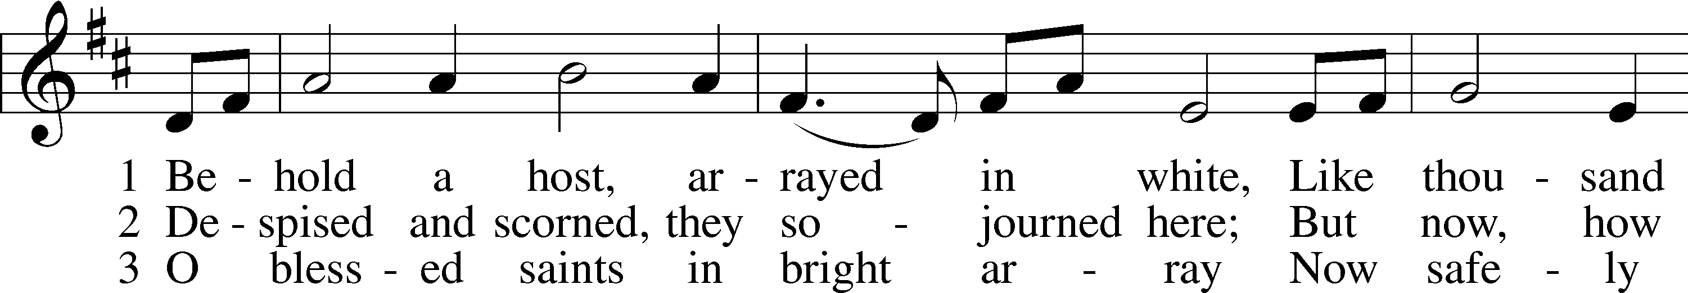

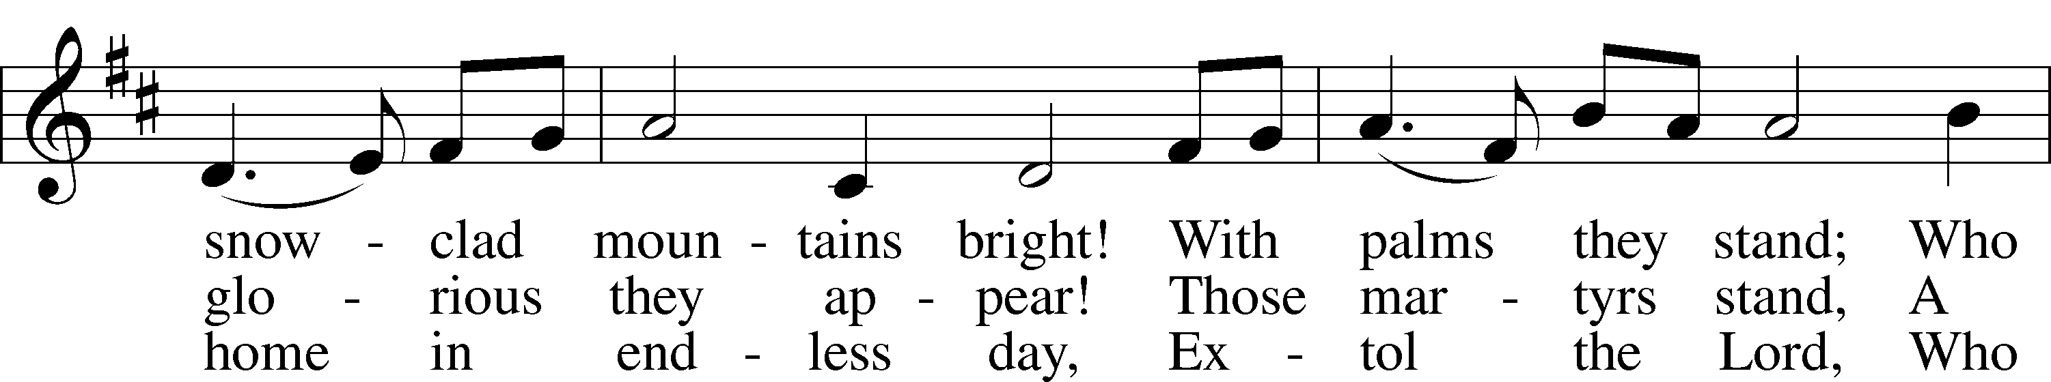

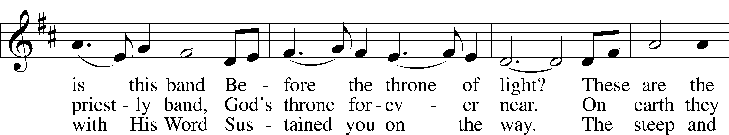

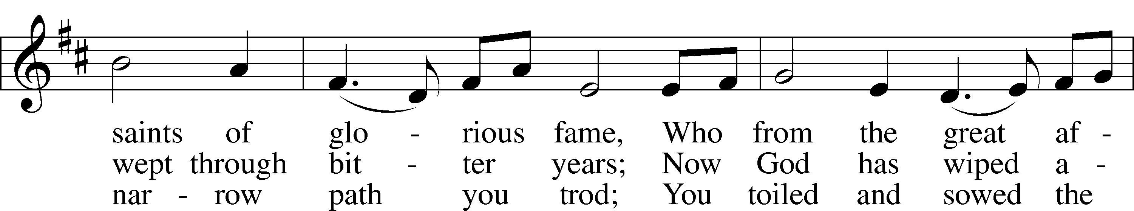

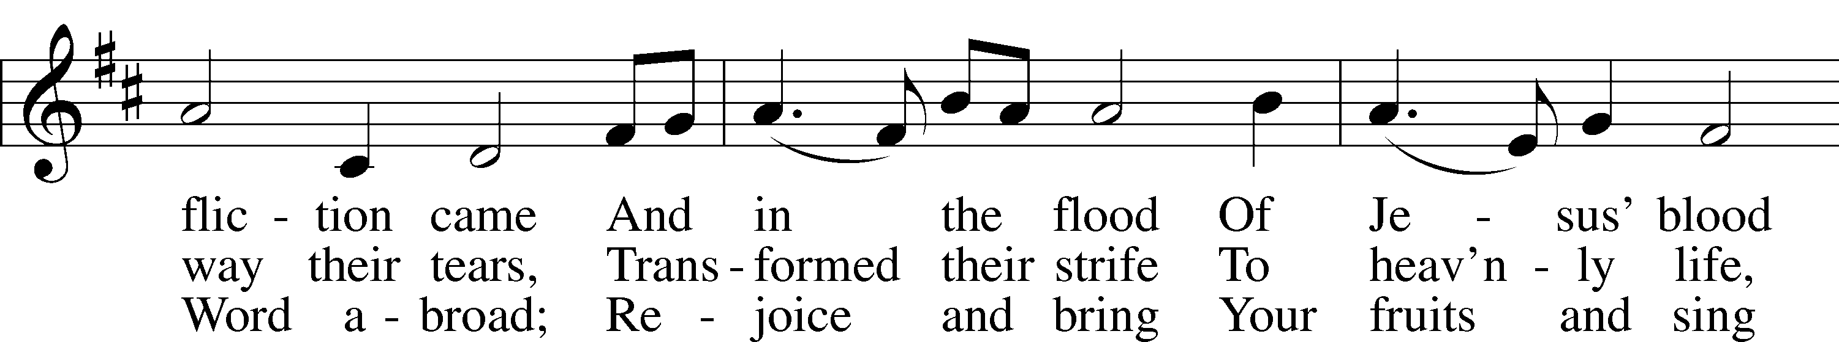

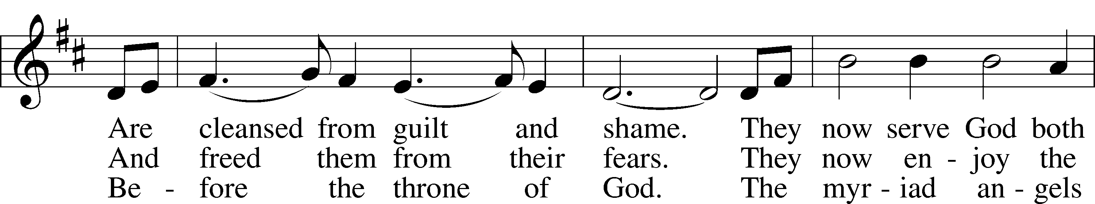

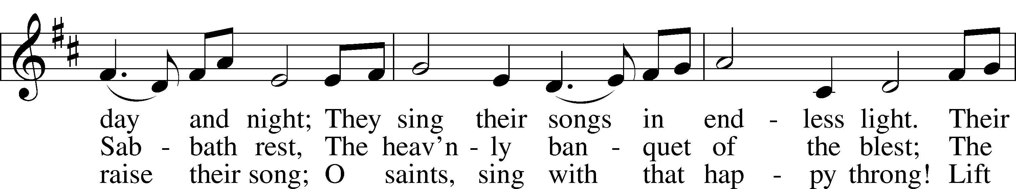

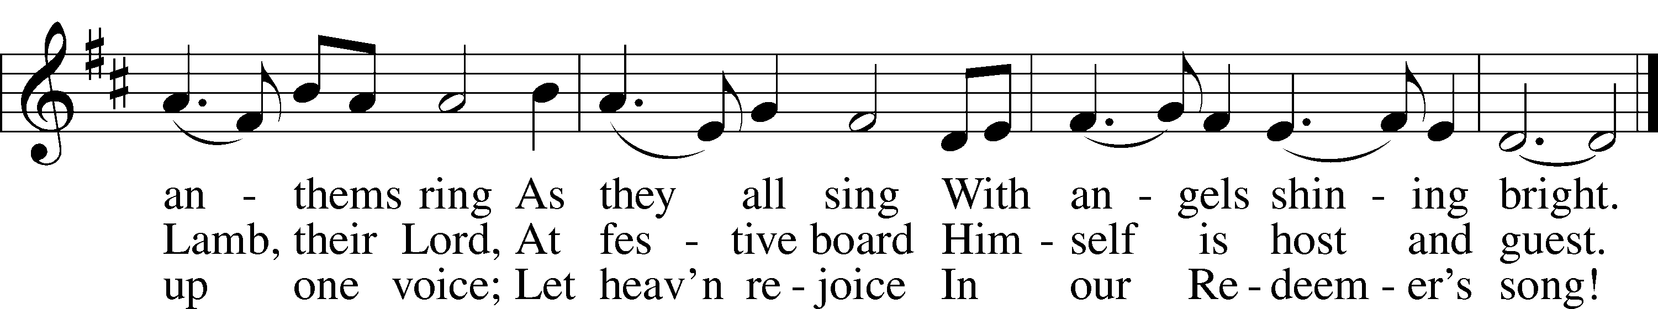

Text: Hans Adolf Brorson, 1694–1764; tr. The Lutheran Hymnal, 1941, alt.  
Tune: Norwegian, 17th cent.  
Text and tune: Public domain

Sermon “I’m But a Stranger Here” *Revelation 7:9-17*

Stand

Nicene Creed

C **I believe in one God,**

**the Father Almighty,**

**maker of heaven and earth**

**and of all things visible and invisible.**

**And in one Lord Jesus Christ,**

**the only-begotten Son of God,**

**begotten of His Father before all worlds,**

**God of God, Light of Light,**

**very God of very God,**

**begotten, not made,**

**being of one substance with the Father,**

**by whom all things were made;**

**who for us men and for our salvation came down from heaven**

**and was incarnate by the Holy Spirit of the virgin Mary**

**and was made man;**

**and was crucified also for us under Pontius Pilate.**

**He suffered and was buried.**

**And the third day He rose again according to the Scriptures**

**and ascended into heaven**

**and sits at the right hand of the Father.**

**And He will come again with glory to judge both the living and the dead,**

**whose kingdom will have no end.**

**And I believe in the Holy Spirit,**

**the Lord and giver of life,**

**who proceeds from the Father and the Son,**

**who with the Father and the Son together is worshiped and glorified,**

**who spoke by the prophets.**

**And I believe in one holy Christian and apostolic Church,**

**I acknowledge one Baptism for the remission of sins,**

**and I look for the resurrection of the dead**

**and the life** T **of the world to come. Amen.**

Prayer of the Church

Sit

Offering

Stand

# Service of the Sacrament

We welcome communicant members of our sister congregations of the LCMS to join us in receiving the Lord's Supper. Other visitors are welcomed forward to receive a blessing. Simply cross your arms to indicate this desire.

Preface LSB 160

P The Lord be with you.

C **And also with you.**

P Lift up your hearts.

C **We lift them to the Lord.**

P Let us give thanks to the Lord our God.

C **It is right to give Him thanks and praise.**

Proper Preface (Abbreviated) LSB 161

P It is truly good, right, and salutary . . . evermore praising You and saying:

Sanctus LSB 161

C **Holy, holy, holy Lord God of pow’r and might:**

**Heaven and earth are full of Your glory.**

**Hosanna. Hosanna.**

**Hosanna in the highest.**

**Blessed is He who comes in the name of the Lord.**

**Hosanna in the highest.**

Lord’s Prayer LSB 162

P Lord, remember us in Your kingdom and teach us to pray:

C **Our Father who art in heaven,**

**hallowed be Thy name,**

**Thy kingdom come,**

**Thy will be done on earth**

**as it is in heaven;**

**give us this day our daily bread;**

**and forgive us our trespasses**

**as we forgive those**

**who trespass against us;**

**and lead us not into temptation,**

**but deliver us from evil.**

**For Thine is the kingdom**

**and the power and the glory**

**forever and ever. Amen.**

The Words of Our Lord

P Our Lord Jesus Christ, on the night when He was betrayed, took bread, and when He had given thanks, He broke it and gave it to the disciples and said: “Take, eat; this is My T body, which is given for you. This do in remembrance of Me.”

In the same way also He took the cup after supper, and when He had given thanks, He gave it to them, saying: “Drink of it, all of you; this cup is the new testament in My T blood, which is shed for you for the forgiveness of sins. This do, as often as you drink it, in remembrance of Me.”

Pax Domini LSB 163

P The peace of the Lord be with you always.

C **Amen.**

Agnus Dei LSB 163

C **Lamb of God, You take away the sin of the world; have mercy on us.**

**Lamb of God, You take away the sin of the world; have mercy on us.**

**Lamb of God, You take away the sin of the world; grant us peace.**

Sit

Distribution

940 Holy God, We Praise Thy Name sts. 1–5

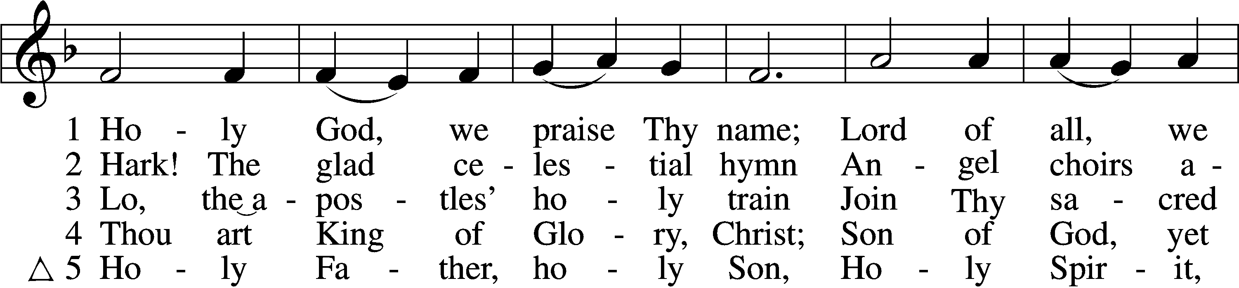

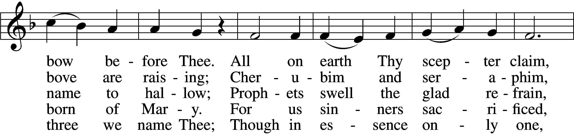

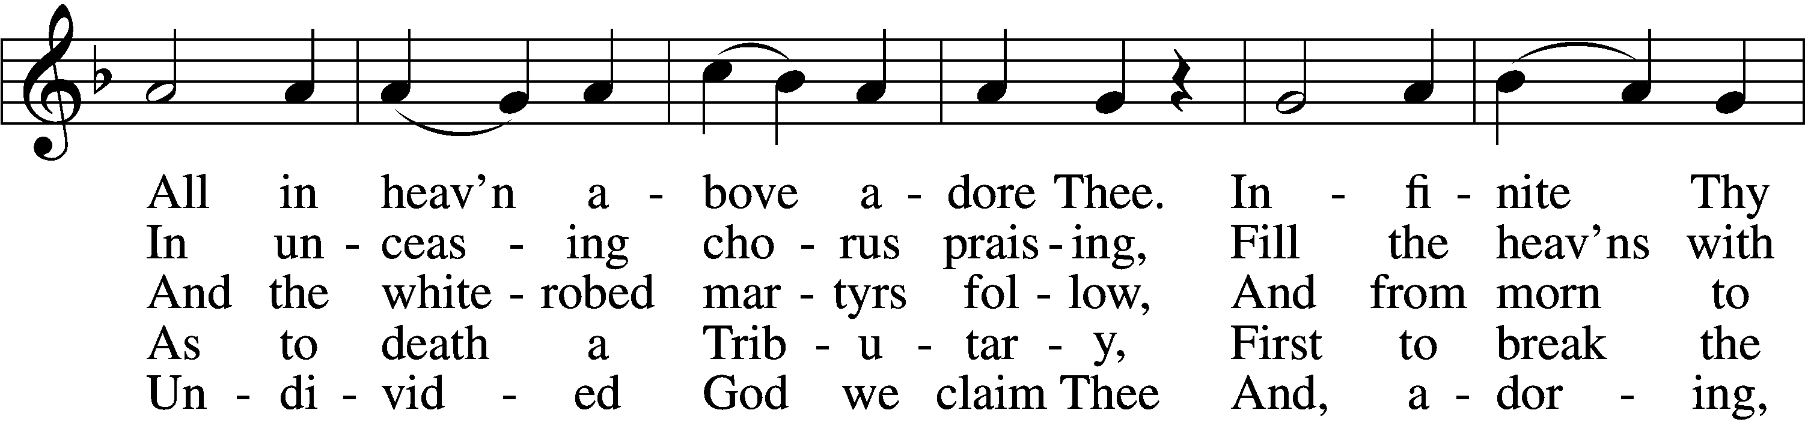

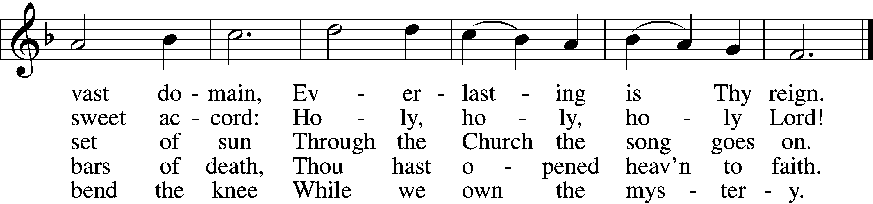

Text: Latin, c. 4th cent.; German version Katholisches Gesangbuch, 1774, Vienna; tr. Clarence A. Walworth, 1820–1900, alt.  
Tune: Katholisches Gesangbuch, 1774, Vienna  
Text and tune: Public domain

639 Wide Open Stand the Gates

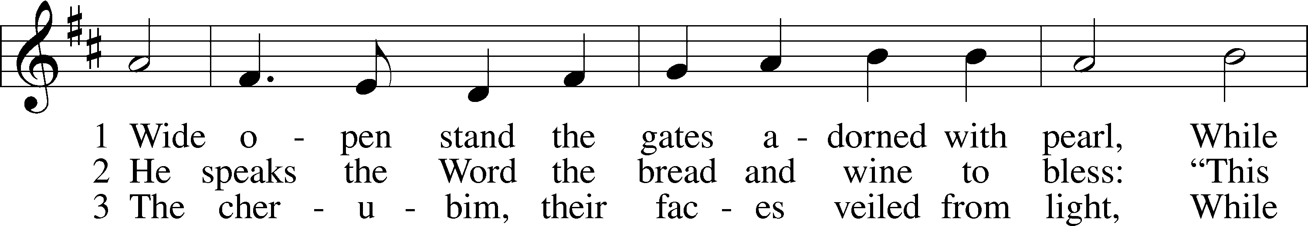

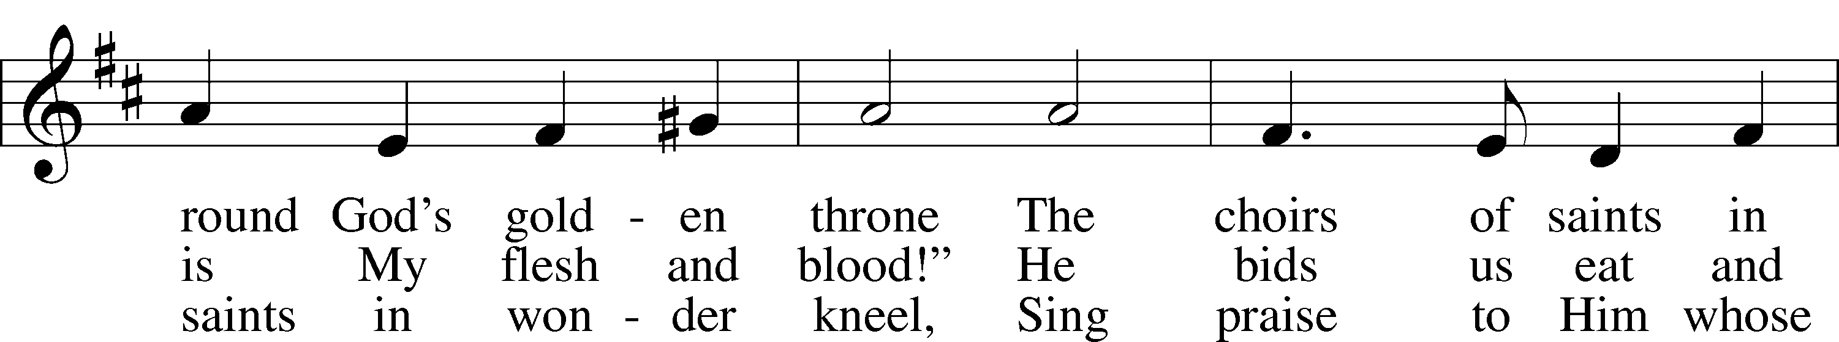

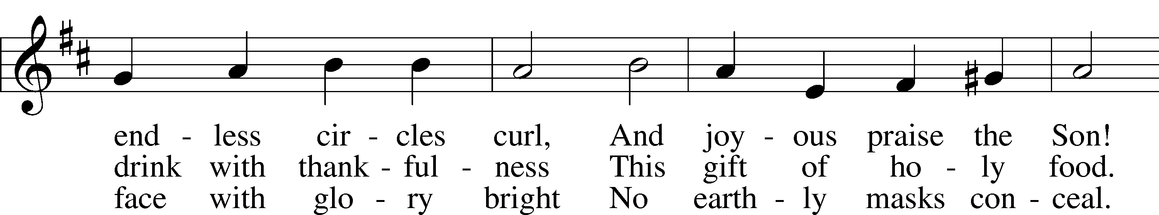

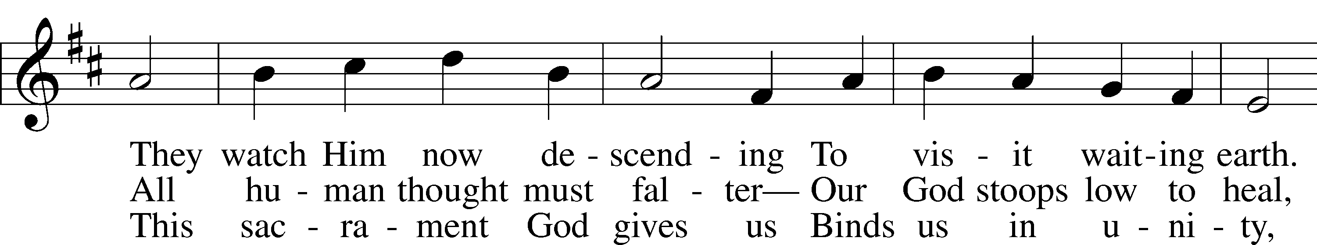

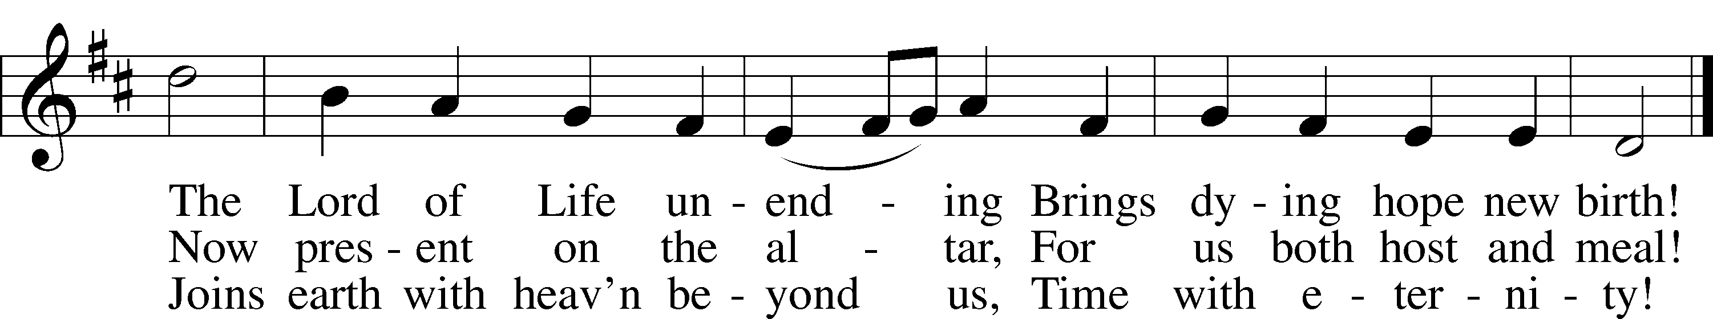

Text: J. K. Wilhelm Loehe, 1808–72; tr. Herman G. Stuempfle, Jr., 1923–2007  
Tune: Christlich Neu-vermehrt . . . Gesangbuch, 1663, Erfurt  
Text: © 2002 GIA Publications, Inc. Used by permission: LSB Hymn License no. 110001822  
Tune: Public domain

672 Jerusalem the Golden

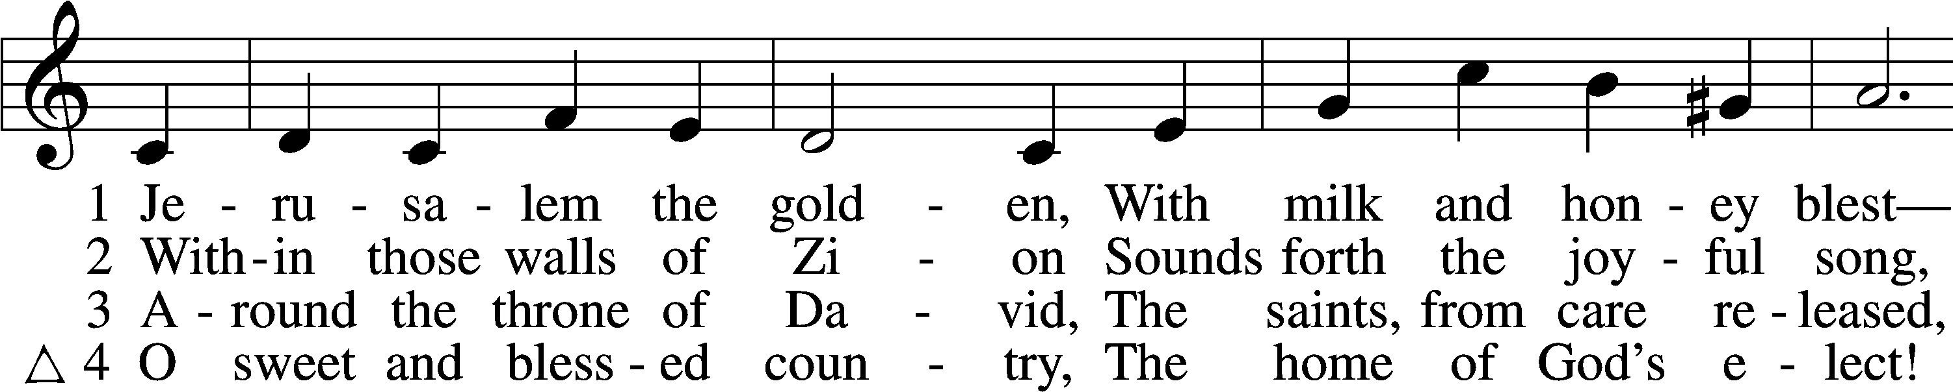

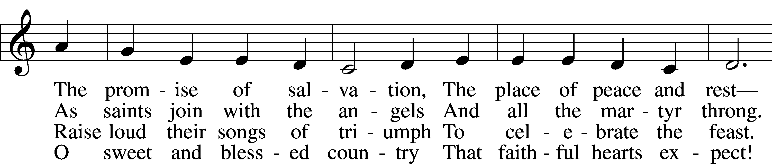

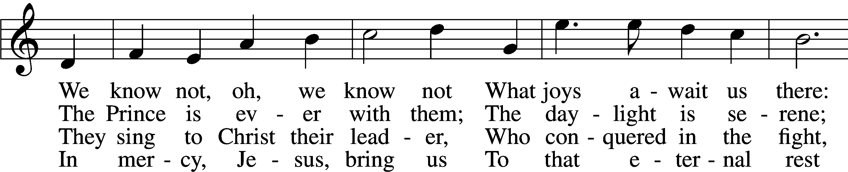

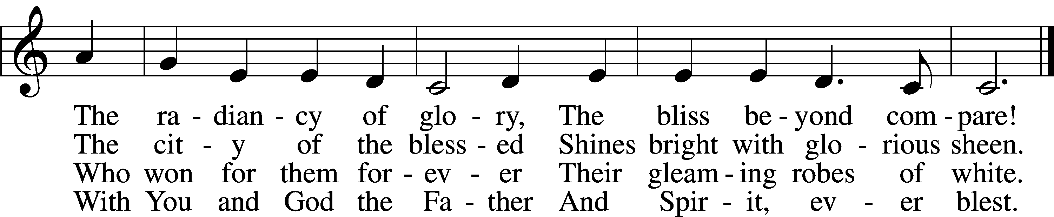

Text: Bernard of Cluny, 12th cent.; tr. John Mason Neale, 1818–66, alt.  
Tune: Alexander C. Ewing, 1830–95, alt.  
Text and tune: Public domain

670 Ye Watchers and Ye Holy Ones

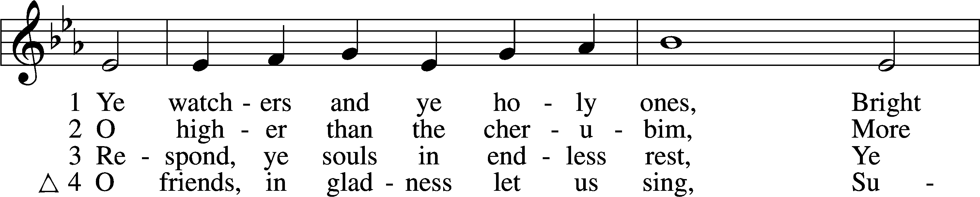

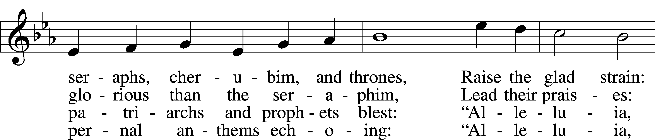

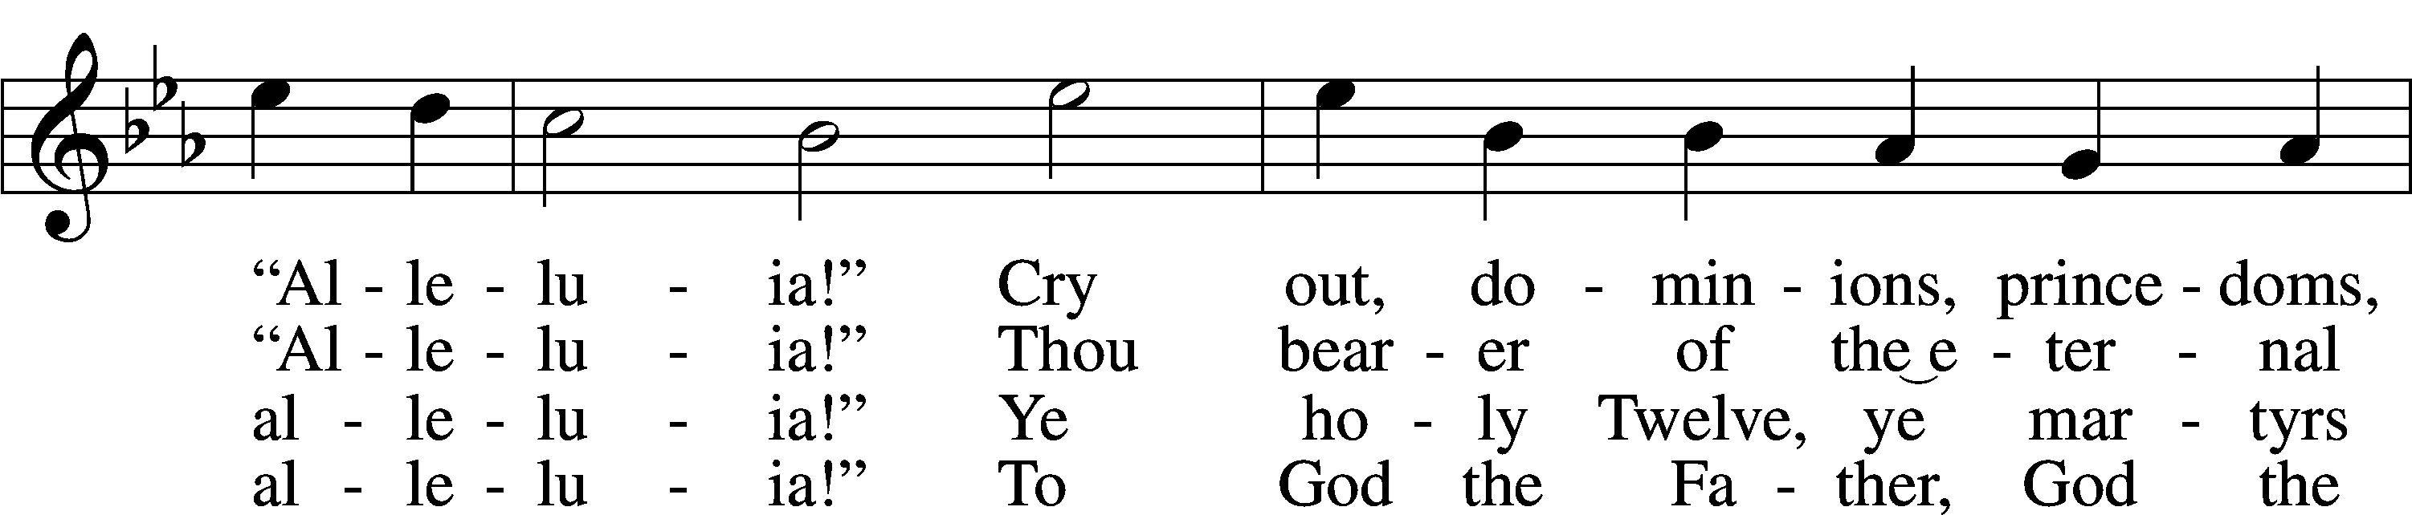

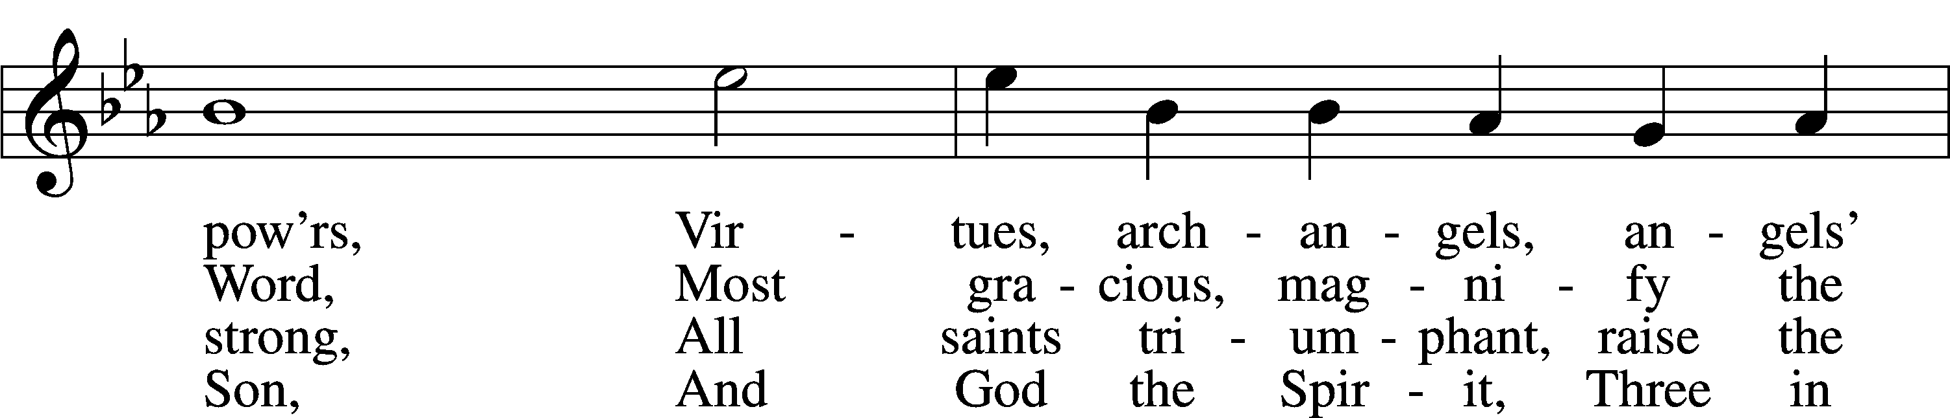

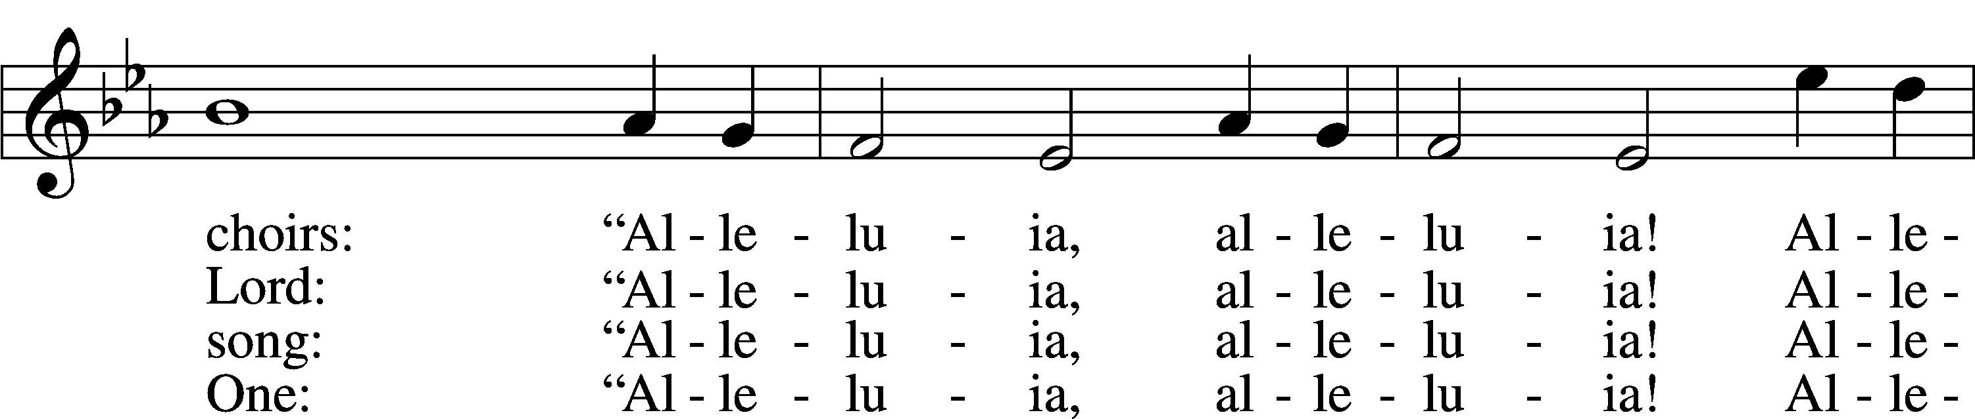

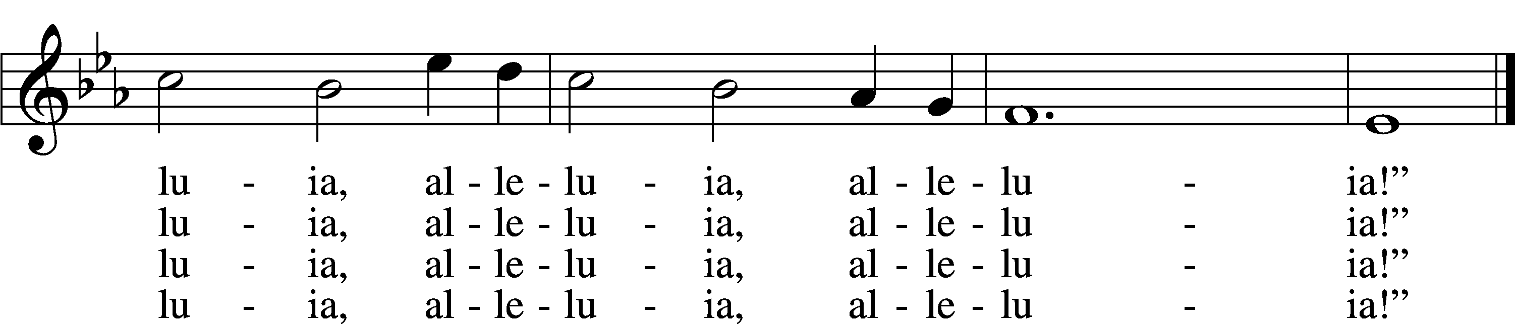

Text: J. Athelstan L. Riley, 1858–1945, alt.  
Tune: Geistliche Kirchengesäng, 1623, Köln  
Text and tune: Public domain

Stand

Thank the Lord LSB 164

C **Thank the Lord and sing His praise; tell ev’ryone what He has done.**

**Let all who seek the Lord rejoice and proudly bear His name.**

**He recalls His promises and leads His people forth in joy**

**with shouts of thanksgiving. Alleluia, alleluia.**

Post-Communion Collect

A Let us pray.

We give thanks to You, almighty God, that You have refreshed us through this salutary gift, and we implore You that of Your mercy You would strengthen us through the same in faith toward You and in fervent love toward one another; through Jesus Christ, Your Son, our Lord, who lives and reigns with You and the Holy Spirit, one God, now and forever.

C **Amen.**

Benediction LSB 166

P The Lord bless you and keep you.

The Lord make His face shine on you and be gracious to you.

The Lord look upon you with favor and T give you peace.

C **Amen.**

517 By All Your Saints in Warfare sts. 1, 4, 3

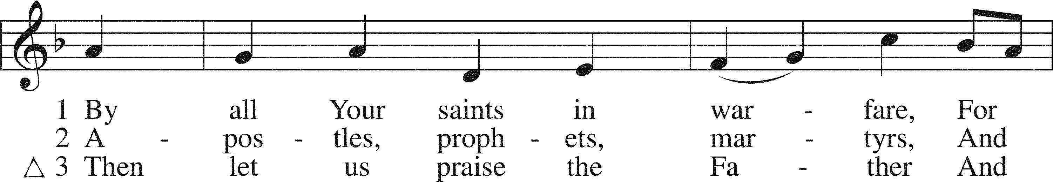

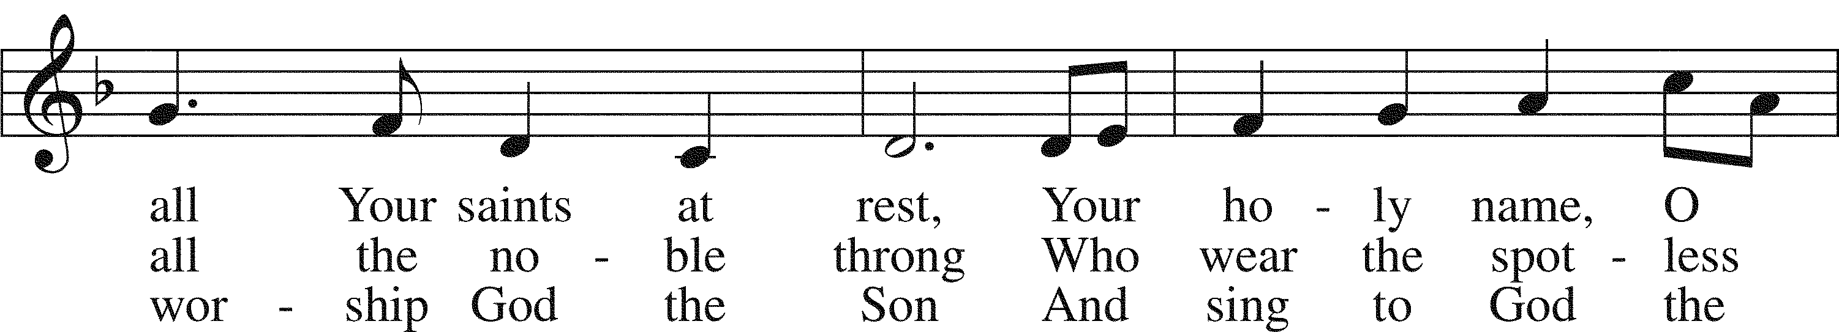

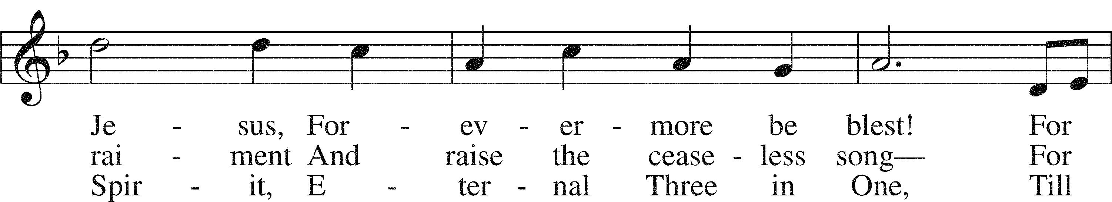

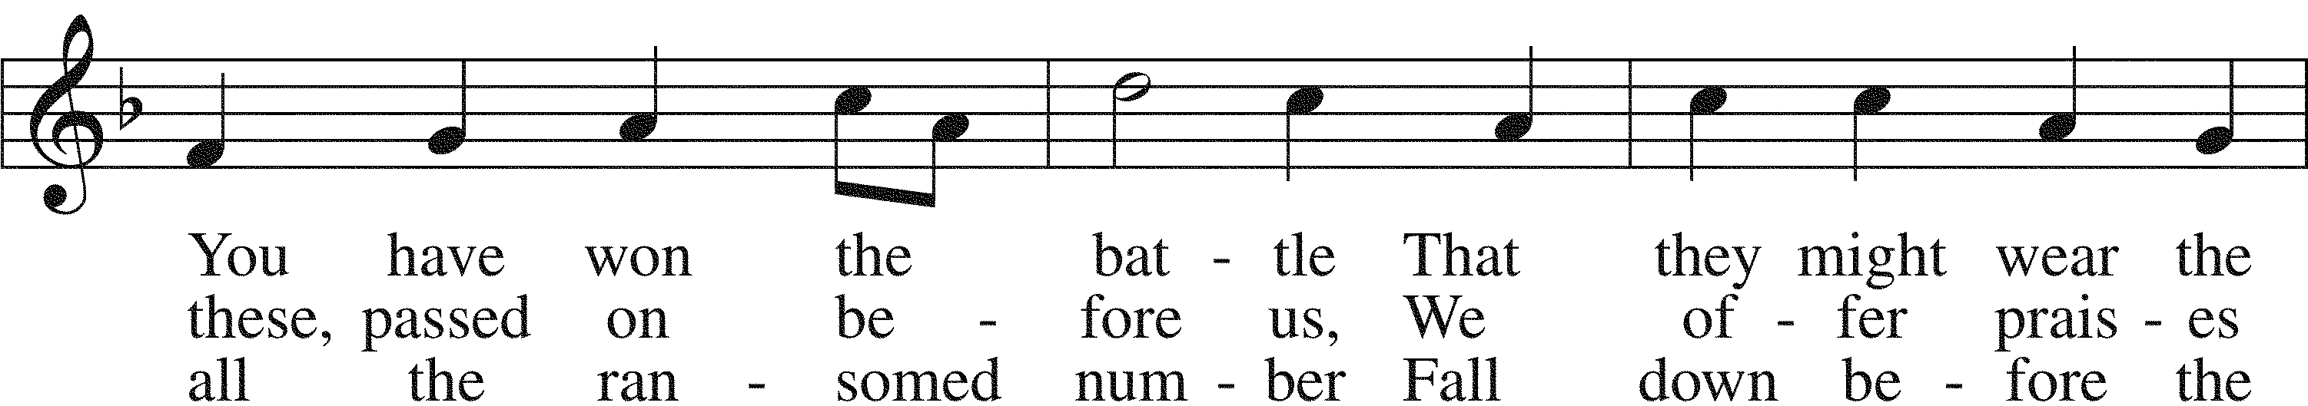

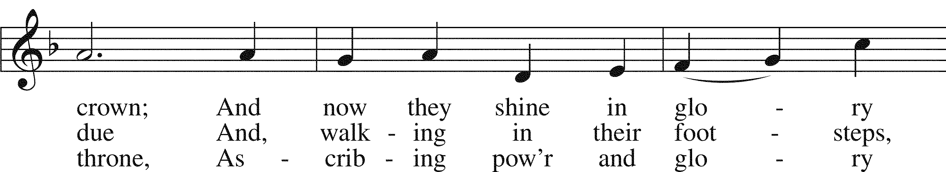

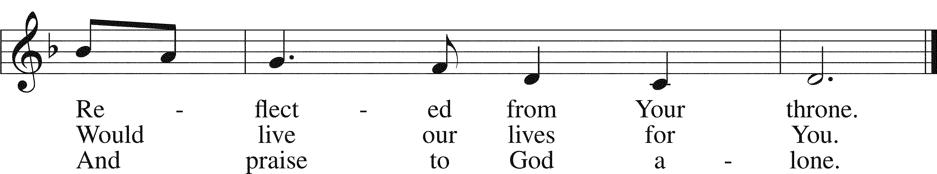

Text: Horatio Bolton Nelson, 1823–1913, alt.  
Tune: English; coll. and arr. Ralph Vaughan Williams, 1872–1958  
Text: Public domain  
Tune: Public domain

Acknowledgments

Unless otherwise indicated, Scripture quotations are from the ESV® Bible (The Holy Bible, English Standard Version®), copyright © 2001 by Crossway, a publishing ministry of Good News Publishers. Used by permission. All rights reserved.

Created by Lutheran Service Builder © 2024 Concordia Publishing House.

**Opportunities for Growth**

This Sunday 8:00 a.m. Divine Service

9:30 a.m. Sunday School/Bible Study

10:45 a.m. Divine Service

Monday 6:00 p.m. Bell Choir

Wednesday 4:30 p.m. Children’s Choir

5:00-7:00 p.m. Christ Academy

Saturday 9:00 a.m. Men’s Bible Study

Next Sunday 8:00 a.m. Divine Service

9:30 a.m.  Sunday School/Bible Study

10:45 a.m. Divine Service

**All Saints’s Day** We celebrate God’s goodness and mercy as we remember those who have fallen asleep in Jesus this year and who have been raised to new life in the glorious presence of our Almighty God: Floyd Foreman, Betty Goos, Barb Kallesen, Chris Rochleau, Betty Schultz, Wade Stephenson, Eileen Termuende, Jean Volkens, and Mary Ann Wege.

**News and Notes**

**The Pancake Man** is at the Early Childhood Center today from 11:00am to 1:30pm. Come, enjoy pancakes and good fellowship and help support one of our main missions.

**Christ Academy Meal:** the hospitality team will provide the main dish. Please bring a side dish, salad or dessert to share. If you would like to sponsor a complete meal, the sign -up sheet is downstairs by the coffee pot. If you have questions, please call Karen Burns of the Hospitality Team (712-309-1070).

You are invited to a **Bride-To-Be-Brunch** in honor of Laura Jean Wurdeman on November 16th, here at St. Paul’s. Please R.S.V.P. to Paige at (712)-307-2399. Laura and Adam are registered at Target and Amazon. Website: adamandlaura.minted.us.

**Catechism**

*The Ninth Commandment:* You shall not covet your neighbor’s house.

*What does this mean?* We should fear and love God so that we do not scheme to get our neighbor’s inheritance or house, or get it in a way which only appears right, but help and be of service to him in keeping it.

**St. Paul’s Evangelical Lutheran Church St. Paul’s Early Childhood Center**

239 Frank St. 1500 N. 16th St.

Council Bluffs, IA 51503 Council Bluffs, IA 51503

712-322-4729 712-322-3294

[www.stpaulscouncilbluffs.org](http://www.stpaulscouncilbluffs.org) [www.splecc.org](http://www.splecc.org)

**Senior** **Pastor** - Rev. Nathan Sherrill **Director** - Becca Heinicke

**St. Paul’s Evangelical Lutheran Church St. Paul’s Early Childhood Center**

239 Frank St. 1500 N. 16th St.

Council Bluffs, IA 51503 Council Bluffs, IA 51503

712-322-4729 712-322-3294

[www.stpaulscouncilbluffs.org](http://www.stpaulscouncilbluffs.org) [www.splecc.org](http://www.splecc.org)

**Senior** **Pastor** - Rev. Nathan Sherrill **Director** - Becca Heinicke

Cell: 712-310-4248 [becca.heinicke@splecc.org](mailto:becca.heinicke@splecc.org)

[Nathansherrill1978@gmail.com](mailto:Nathansherrill1978@gmail.com)  **Administrative Assistant** – Glennda Hedlund

**Associate Pastor/Kantor** - Rev. Timothy Frank [glennda.hedlund@splecc.org](mailto:glennda.hedlund@splecc.org)

Cell: 712-269-3683 School Office Hours

[pastorfrank239@gmail.com](mailto:pastorfrank239@gmail.com) Monday-Friday 8:30 a.m. – 2:30 p.m.

**Pastors Emeriti** - Rev. James Tews & Rev. Robert Lindau

**St. Paul’s Music Conservatory**

**Parish Administrator** - Heidi Bernhards 239 Frank St.

[splccboffice@splccb.org](mailto:splccboffice@splccb.org) Council Bluffs, IA 51503

Church Office Hours: 712-322-8832

Monday-Thursday 8 a.m. – 4 p.m. **Administrator** - Rev. Timothy Frank

Friday 8 a.m. - noon Cell: 712-269-3683

[pastorfrank239@gmail.com](mailto:pastorfrank239@gmail.com)