Midweek Lenten Service
March 4, 2026
Responsive Prayer 2

Hymn: Go to Dark Gethsemane LSB 436
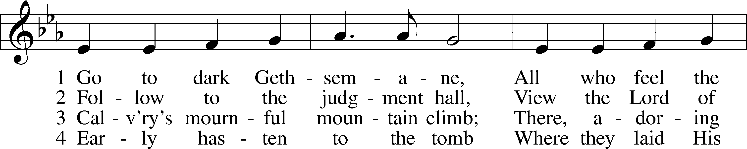
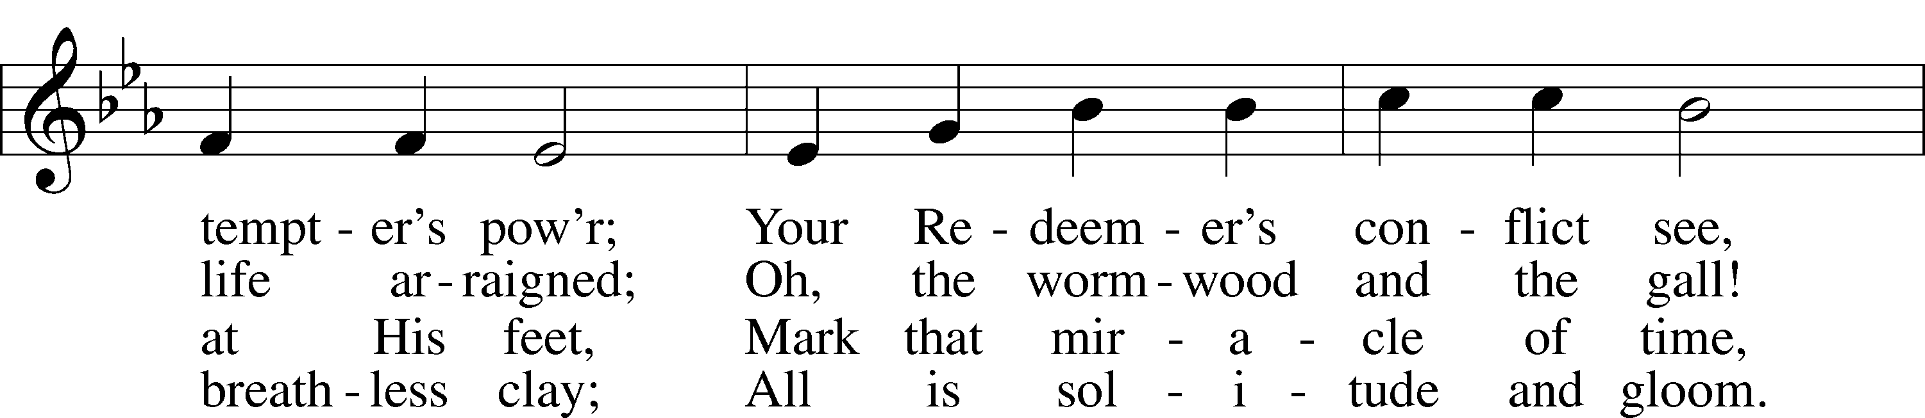
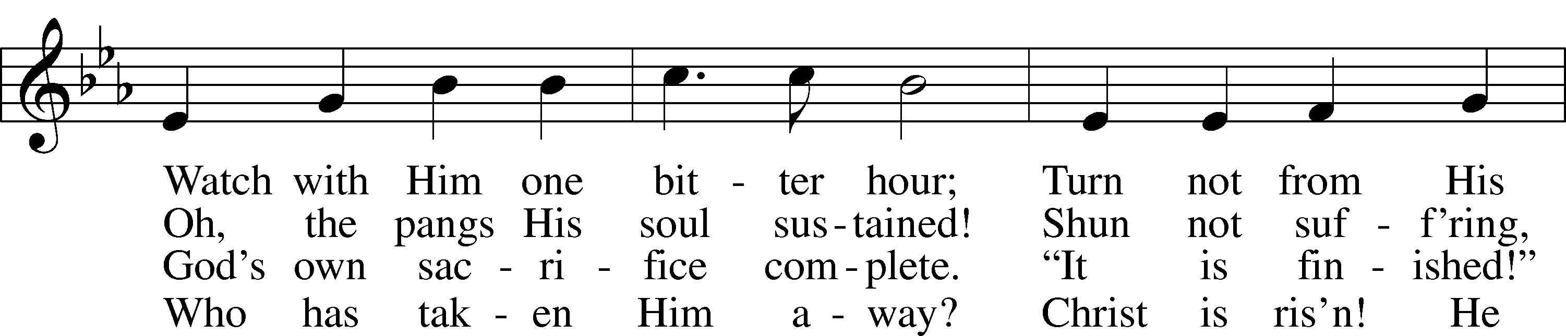
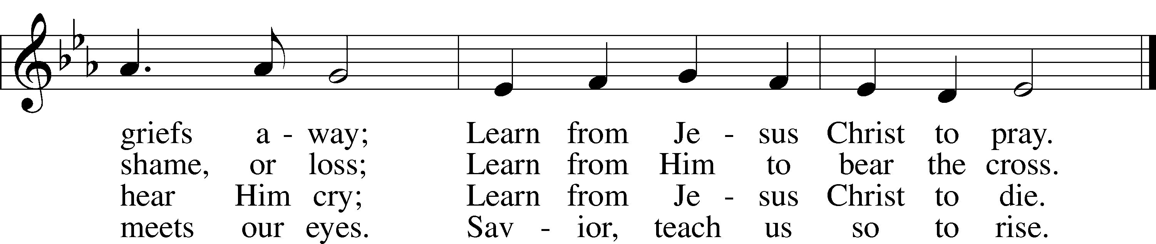
Text: James Montgomery, 1771–1854
Tune: Richard Redhead, 1820–1901
Text and tune: Public domain

Opening Versicles LSB 285
L O Lord, open my lips,
C and my mouth will declare Your praise.
L Make haste, O God, to deliver me;
C make haste to help me, O Lord.
Glory be to the Father and to the Son and to the Holy Spirit;
as it was in the beginning, is now, and will be forever. Amen.
Psalm Psalm 121
¹I lift up my eyes | to the hills.*
From where does my | help come?
²My help comes | from the Lord,*
who made | heaven and earth.
³He will not let your | foot be moved;*
he who keeps you will not | slumber.
⁴Behold, he who keeps | Israel*
will neither slum- | ber nor sleep.
⁵The Lord is your | keeper;*
the Lord is your shade on your | right hand.
⁶The sun shall not strike | you by day,*
nor the | moon by night.
⁷The Lord will keep you from all | evil;*
he will | keep your life.
⁸The Lord will keep
your going out and your | coming in*
from this time forth and for- | evermore.
Glory be to the Father and to the Son
and to the Holy Spirit;
as it was in the beginning,
is now, and will be forever. Amen.

Reading (recited by the children) Isaiah 53:1-6
Who has believed what they heard from us? And to whom has the arm of the LORD been revealed? ² For he grew up before him like a young plant, and like a root out of dry ground; he had no form or majesty that we should look at him, and no beauty that we should desire him. ³ He was despised and rejected by men; a man of sorrows, and acquainted with grief; and as one from whom men hide their faces he was despised, and we esteemed him not. ⁴ Surely he has borne our griefs and carried our sorrows; yet we esteemed him stricken, smitten by God, and afflicted. ⁵ But he was wounded for our transgressions; he was crushed for our iniquities; upon him was the chastisement that brought us peace, and with his stripes we are healed. ⁶ All we like sheep have gone astray; we have turned every one to his own way; and the LORD has laid on him the iniquity of us all.

Reading Matthew 26:17-56

438 A Lamb Goes Uncomplaining Forth LSB 438
Children Stanza 1
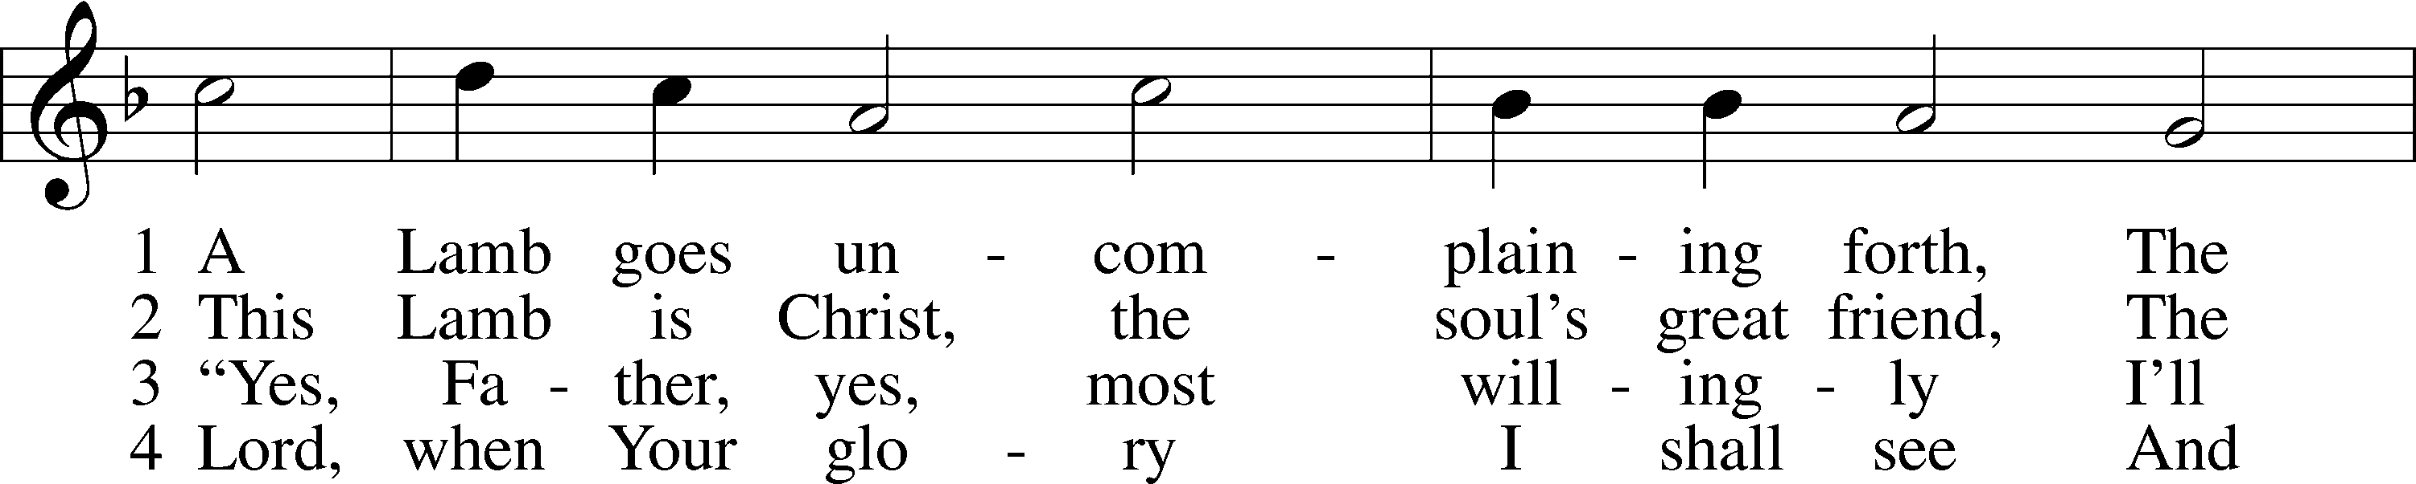
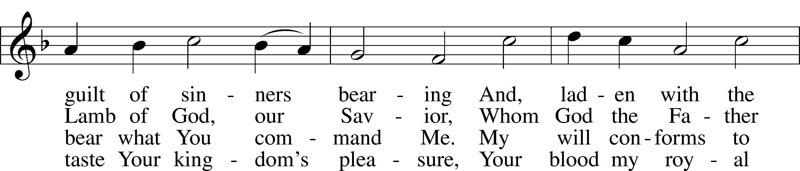
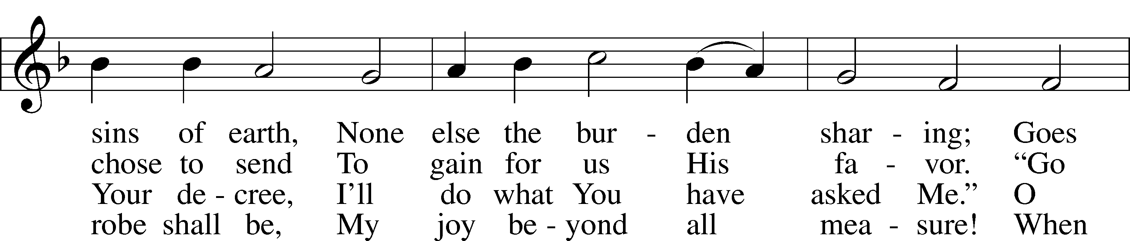
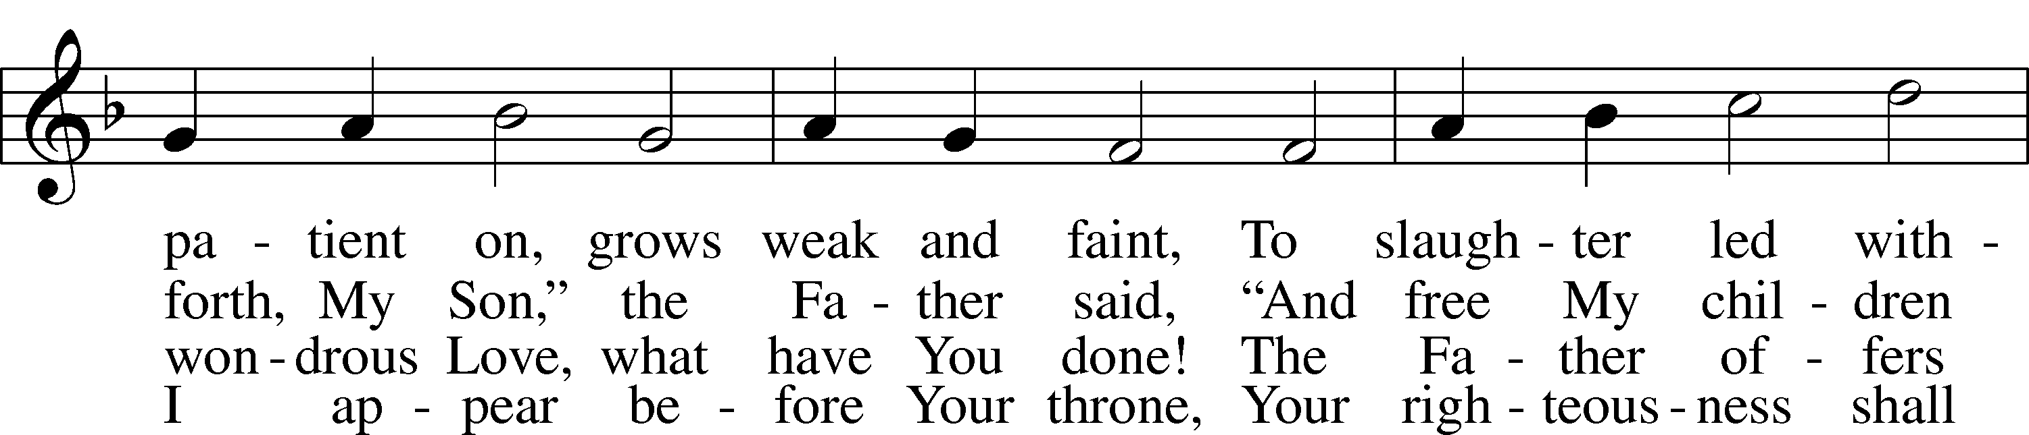
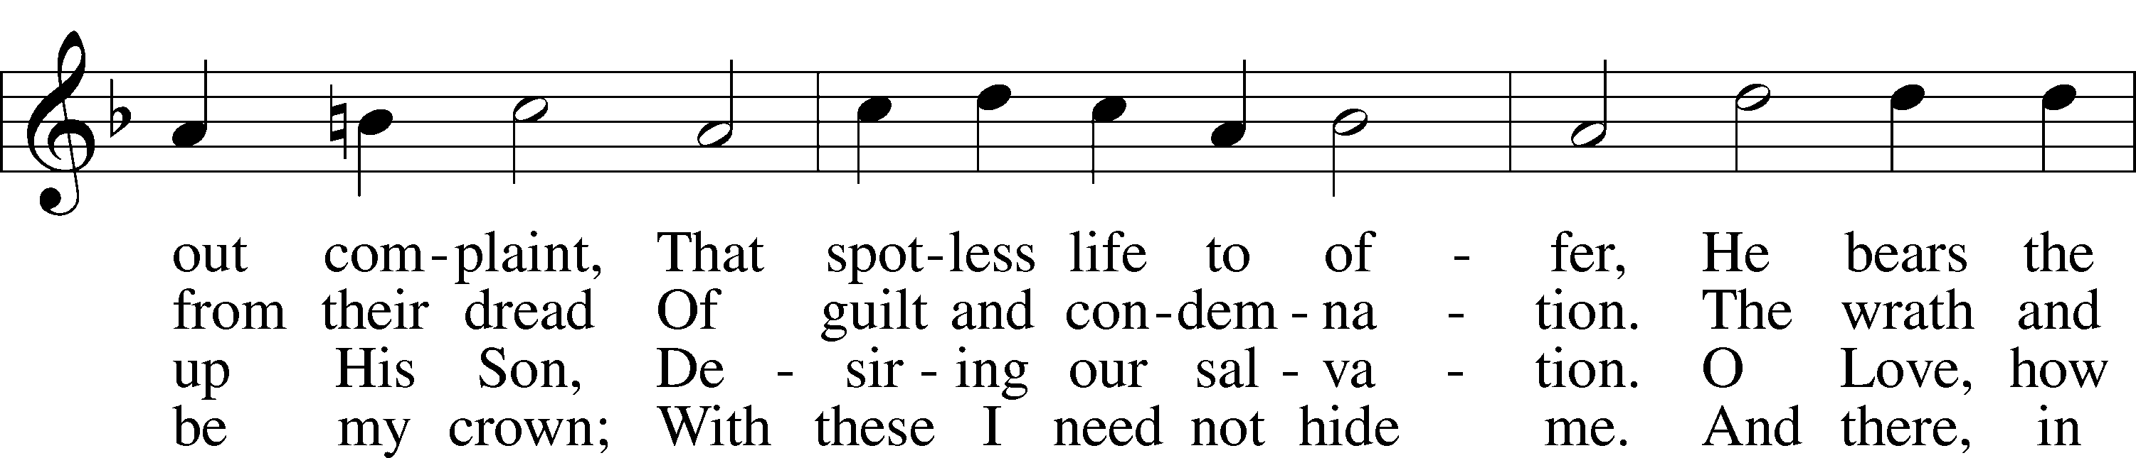
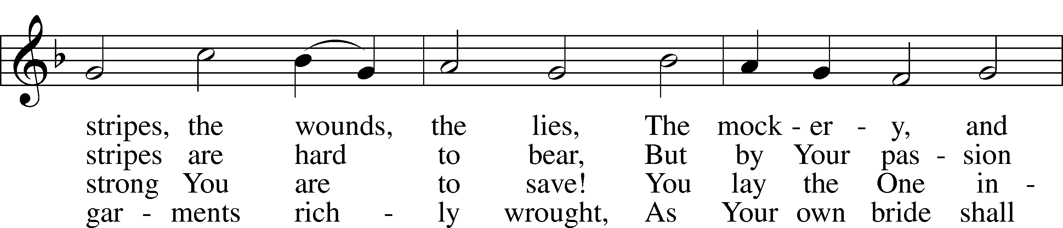
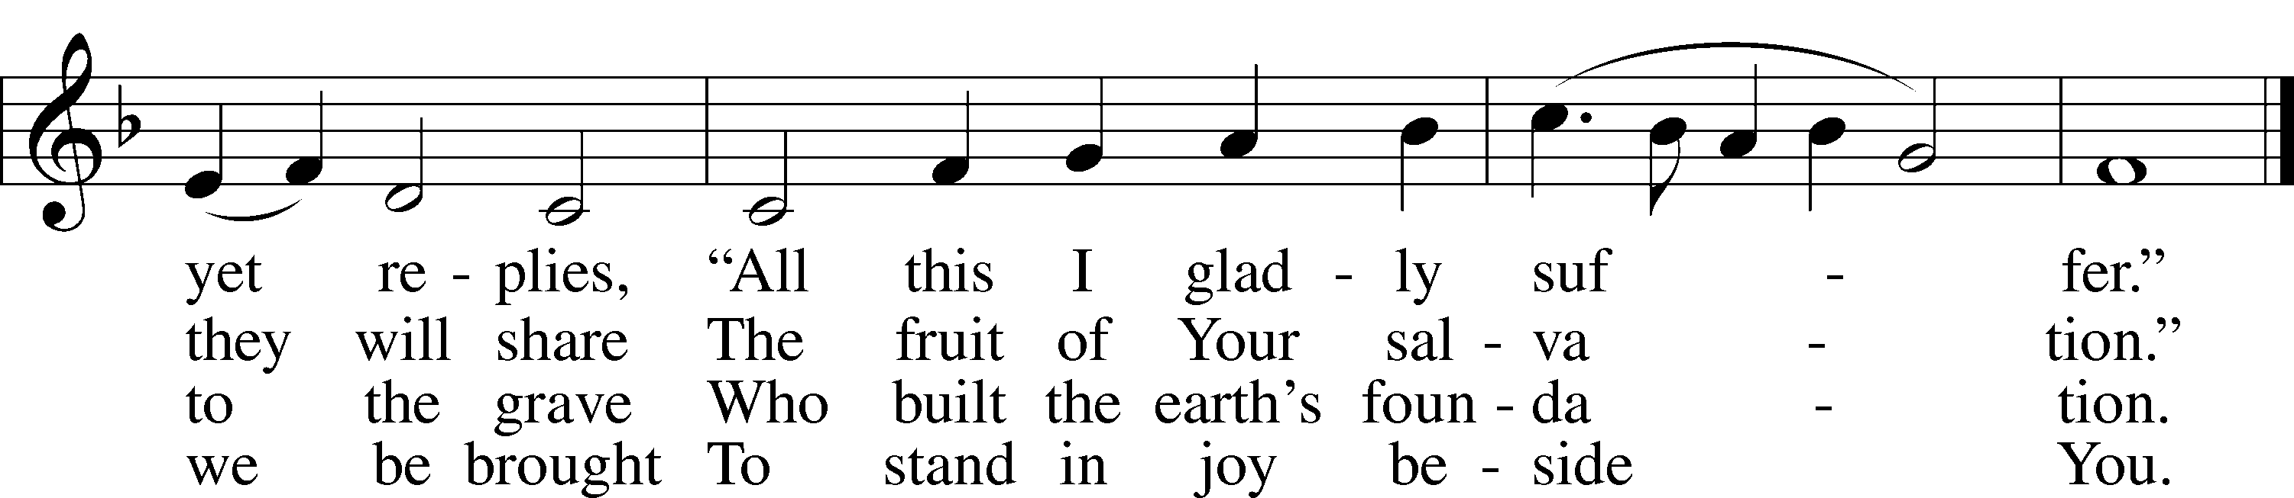
Text: Paul Gerhardt, 1607–76; tr. The Lutheran Hymnal, 1941, alt.
Tune: Wolfgang Dachstein, c. 1487–1553
Text: © 1941 Concordia Publishing House. Used by permission: LSB Hymn License no. 110001822
Tune: Public domain
Sermon: “Jesus was a ‘Man of sorrows.’” Matthew 26:38

Kyrie LSB 285
L O Lord,
C have mercy.
L O Christ,
C have mercy.
L O Lord,
C have mercy.

Lord’s Prayer

Apostles’ Creed
C I believe in God, the Father Almighty,
maker of heaven and earth.
And in Jesus Christ, His only Son, our Lord,
who was conceived by the Holy Spirit,
born of the virgin Mary,
suffered under Pontius Pilate,
was crucified, died and was buried.
He descended into hell.
The third day He rose again from the dead.
He ascended into heaven
and sits at the right hand of God the Father Almighty.
From thence He will come to judge the living and the dead.
I believe in the Holy Spirit,
the holy Christian Church,
the communion of saints,
the forgiveness of sins,
the resurrection of the body,
and the life T everlasting. Amen.

Versicles LSB 286
L Hear my prayer, O Lord;
C let my cry come to You.
L In the day of my trouble I call upon You,
C for You answer me.
L Hide Your face from my sins,
C and blot out all my iniquities.
L Create in me a clean heart, O God,
C and renew a right spirit within me.
L Cast me not away from Your presence,
C and take not Your Holy Spirit from me.
L Restore to me the joy of Your salvation,
C and uphold me with a willing spirit.
L Because Your steadfast love is better than life,
C my lips will praise You.
L For You have been my help,
C and in the shadow of Your wings I will sing for joy.
L Teach me Your way, O Lord, that I may walk in Your truth;
C unite my heart to fear Your name.
L I give thanks to You, O Lord my God, with my whole heart,
C and I will glorify Your name forever.
L May all who seek You rejoice and be glad in You.
C May those who love Your salvation say evermore, “God is great!”
L Save Your people and bless Your heritage!
C Be their shepherd and carry them forever.
L Give ear, O Lord, to my prayer;
C listen to my plea for grace.

Collect of the Day
L Let us pray.
O God, You see that of ourselves we have no strength. By Your mighty power defend us from all adversities that may happen to the body and from all evil thoughts that may assault and hurt the soul; through Jesus Christ, Your Son, our Lord, who lives and reigns with You and the Holy Spirit, one God, now and forever.
C Amen.

Evening Prayer
C I thank You, my heavenly Father, through Jesus Christ, Your dear Son, that You have graciously kept me this day; and I pray that You would forgive me all my sins where I have done wrong, and graciously keep me this night. For into Your hands I commend myself, my body and soul, and all things. Let Your holy angel be with me, that the evil foe may have no power over me.
C Amen.

Benedicamus LSB 287
L Let us bless the Lord.
C Thanks be to God.

Blessing LSB 287
L The Lord bless us, defend us from all evil, and bring us to everlasting life.
C Amen.

420 Christ, the Life of All the Living Children: St. 1
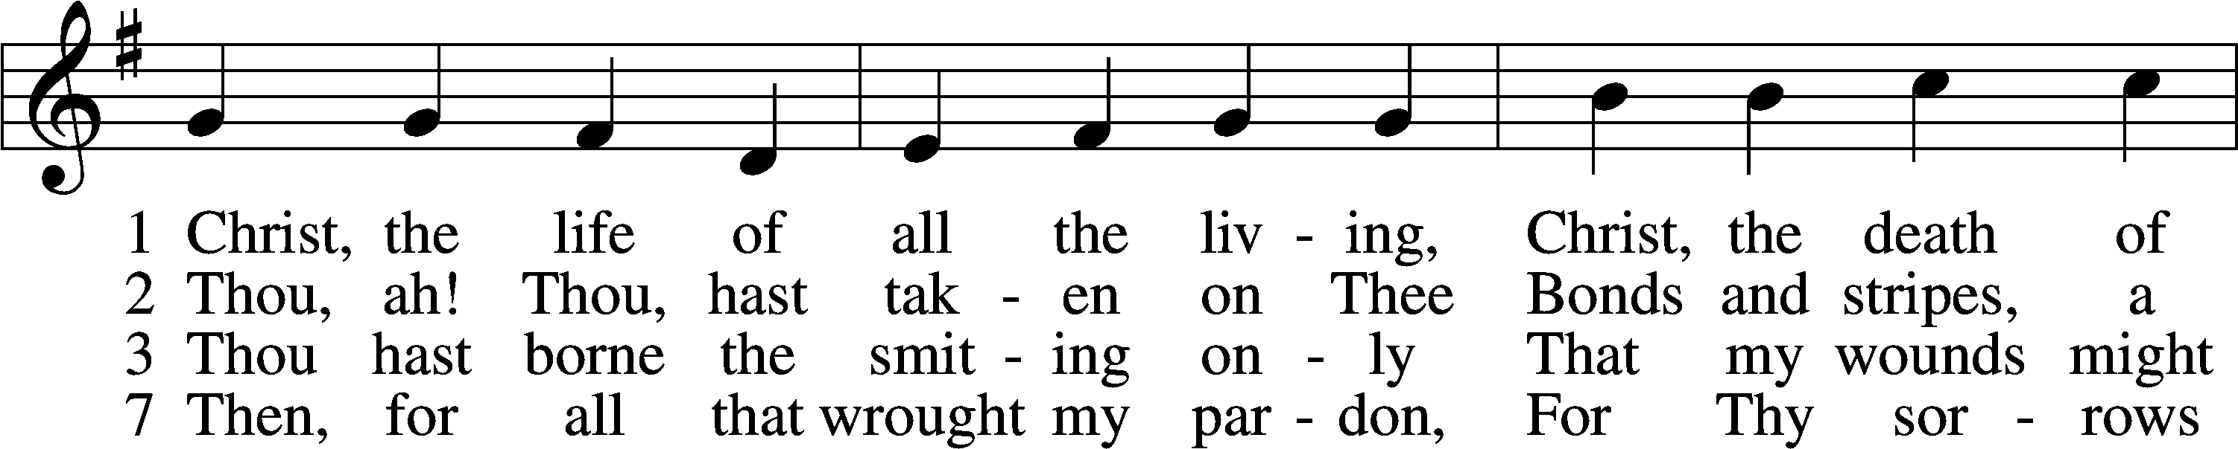
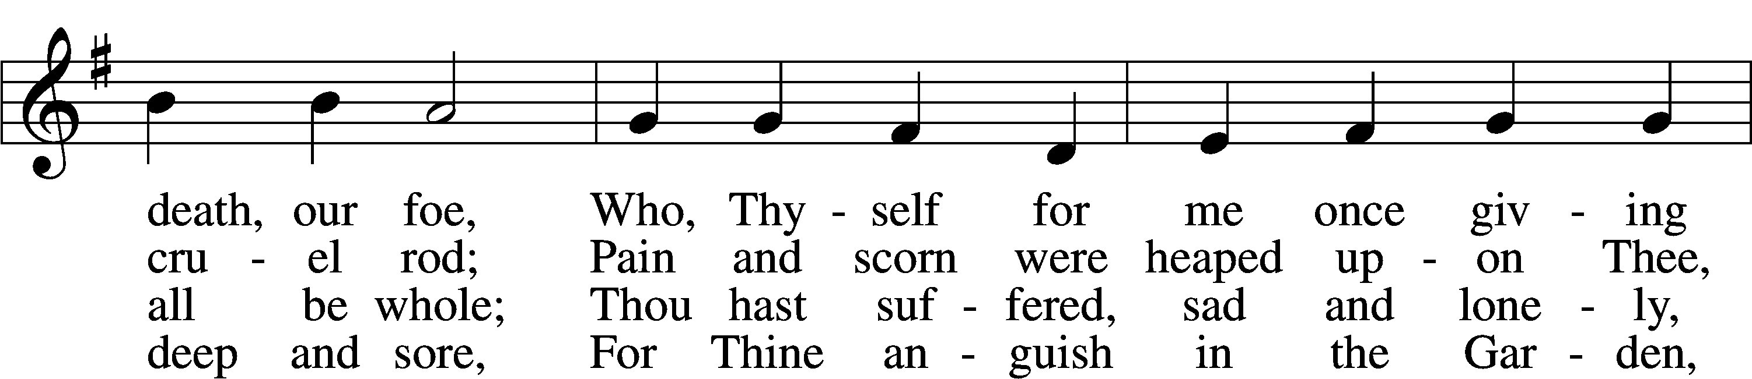
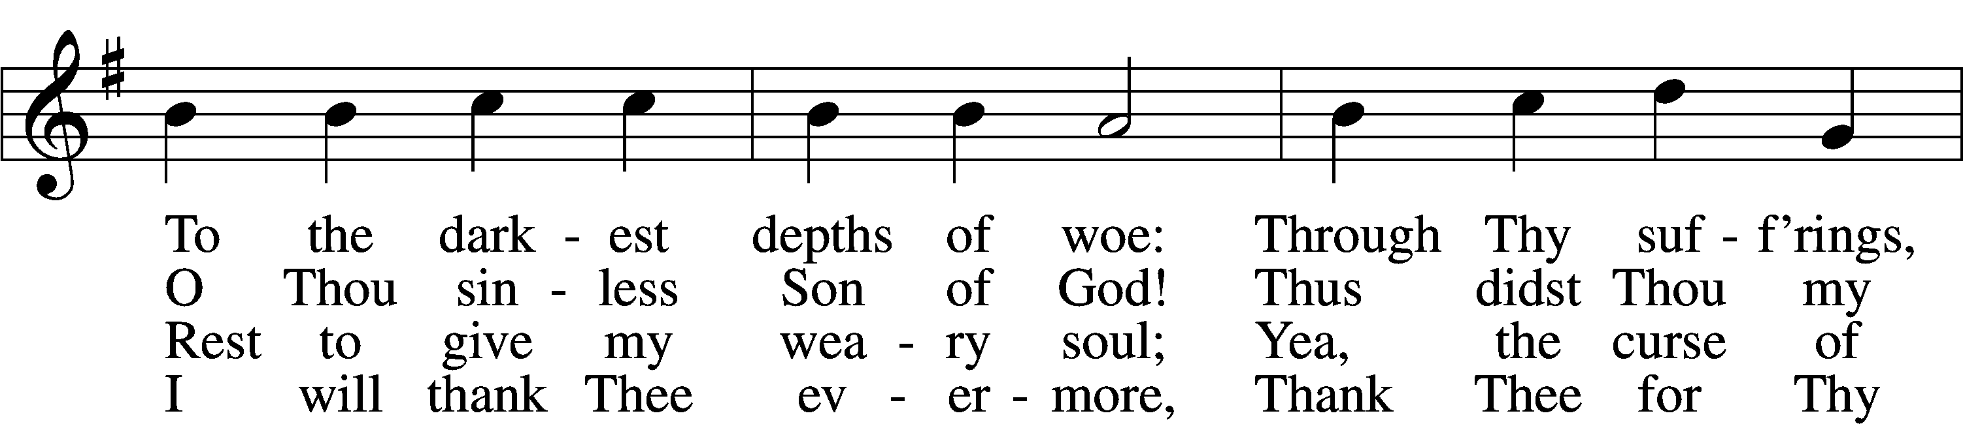
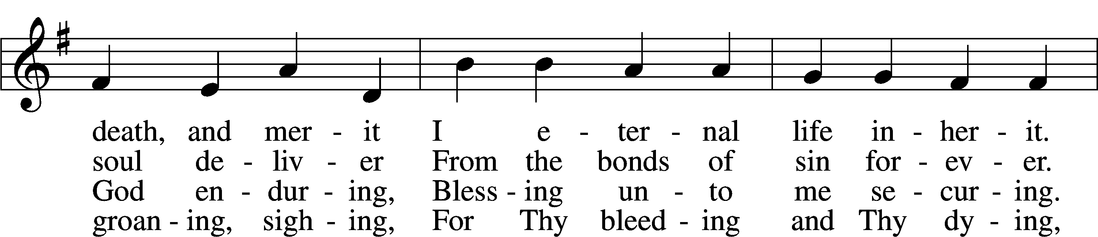
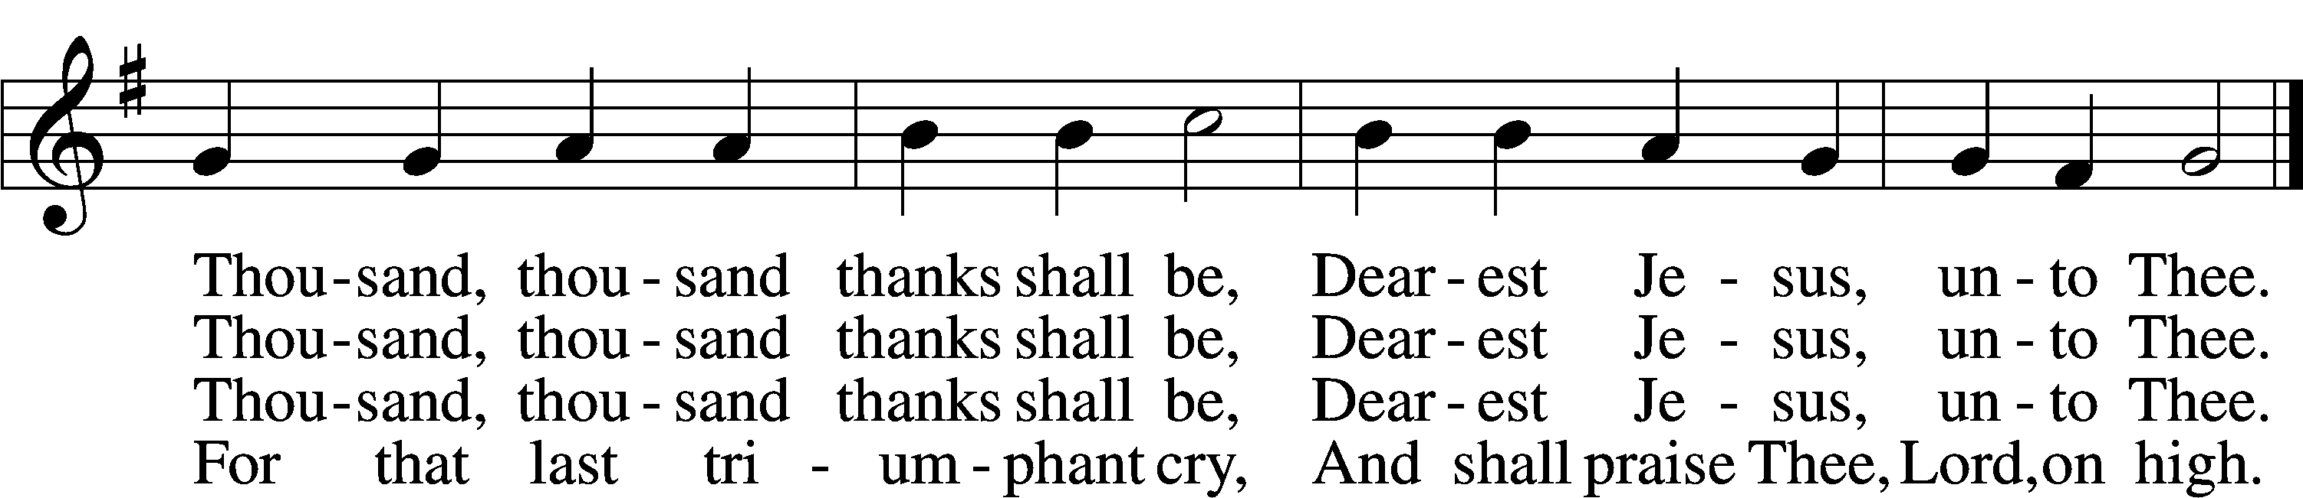
Text: Ernst Christoph Homburg, 1605–81; (sts. 1–2, 7): tr. Catherine Winkworth, 1827–78, alt.; (st. 3): tr. Evangelical Lutheran Hymn-Book, 1912, St. Louis
Tune: Das grosse Cantional, 1687, Darmstadt
Text and tune: Public domain

Acknowledgments
Responsive Prayer 2 from Lutheran Service Book
Unless otherwise indicated, Scripture quotations are from the ESV® Bible (The Holy Bible, English Standard Version®), copyright © 2001 by Crossway, a publishing ministry of Good News Publishers. Used by permission. All rights reserved. Created by Lutheran Service Builder © 2026 Concordia Publishing House.

